

|  |  |
| --- | --- |
| **Student Name:** | **ANDREW HART** |
| **Student Number:** | **W9HDSQ182** |
| **Project Title:** | **WESTERN CAPE TUTORS** |
| **Submission Date:** | **2020/08/11** |

**Contents**

Introduction 3

Prototypes 5

Prototype 1 5

Laptop Screen Size 5

Phone Screen Size 8

Prototype 2 12

Laptop Screen Size 12

Phone Screen Size 14

Client Response to Prototypes 18

Designing 19

Class Responsibility Collaborator cards 19

Enhanced Entity Relationship Diagram 19

Context Diagram 20

Data Flow Diagram 20

Use Case Diagram 21

Database Design 22

Coding 24

Screen shots 24

Home Page 24

Search Page 25

View page 26

Profile page 27

Login/Register splash screen 28

Registration page 29

Login page 30

Login success splash screen 31

Create advertisement page 32

Change password page 33

Delete advertisement page 34

About page part 1 35

About page part 2 36

About page part 3 37

3 examples of my responsiveness on a iPhone x 38

PHP code 39

HTML code 58

JavaScript code 98

CSS code 106

MySQL Table Screen shots 126

Conclusion 136

Sign-Off 136

References 137

# Introduction

Western Cape Tutors is an organization that allows tutors from around the Western Cape to share their profile information to anyone seeking tutor assistance. This website allows a user to browse through a wide variety of tutors within the Western Cape. This program allows a user to filter search results based on location, gender, subjects, and many more, which will narrow down the available tutors best suited for your child. If a user wishes to create an advertisement, he/she will be required to register first, where after they will be prompted to log in. After the user has logged in to the server, he/she will then be able to post all of their details regarding their tutor position to the database. This advertisement will include details such as experience, transport status, age ranges, and many more.

# Prototypes

## Prototype 1

### Laptop Screen Size

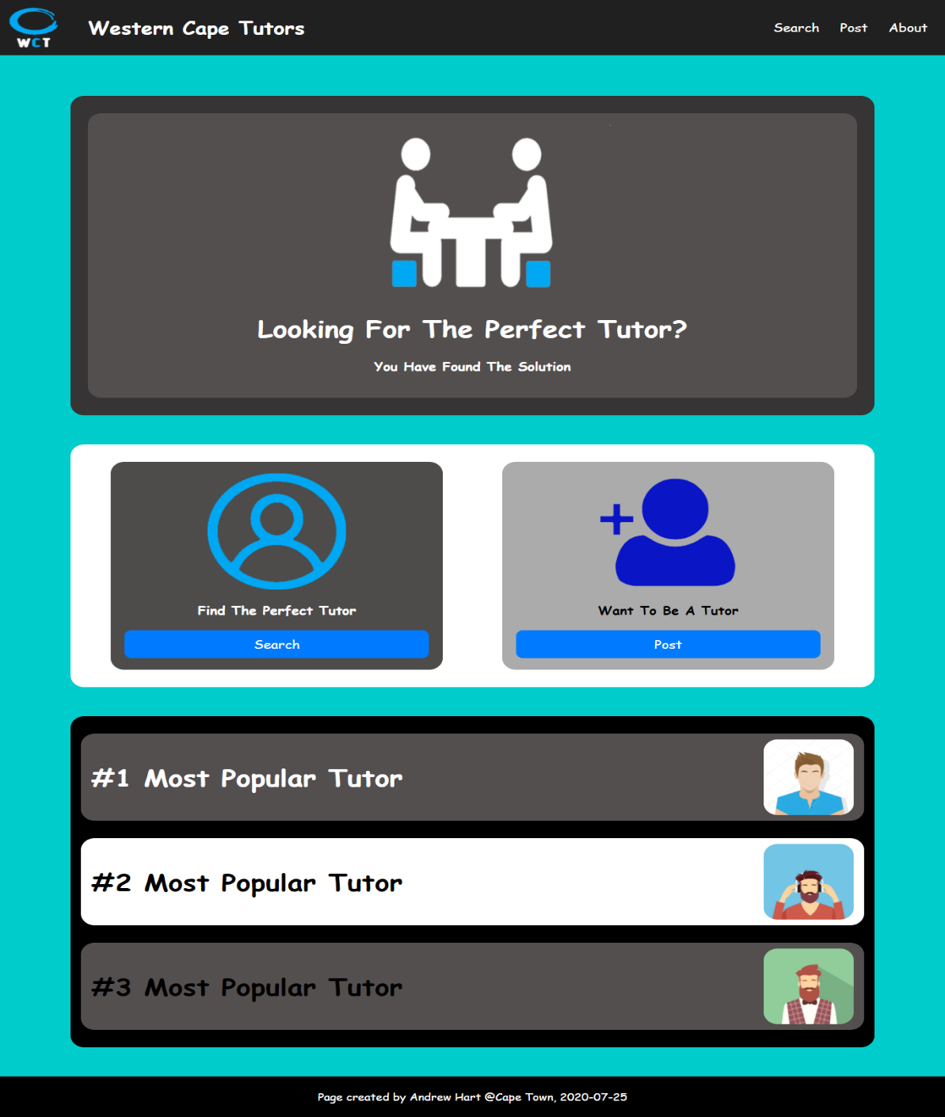

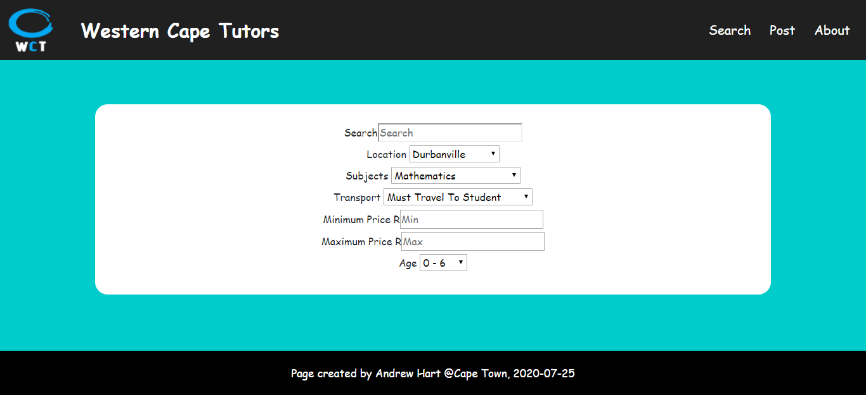

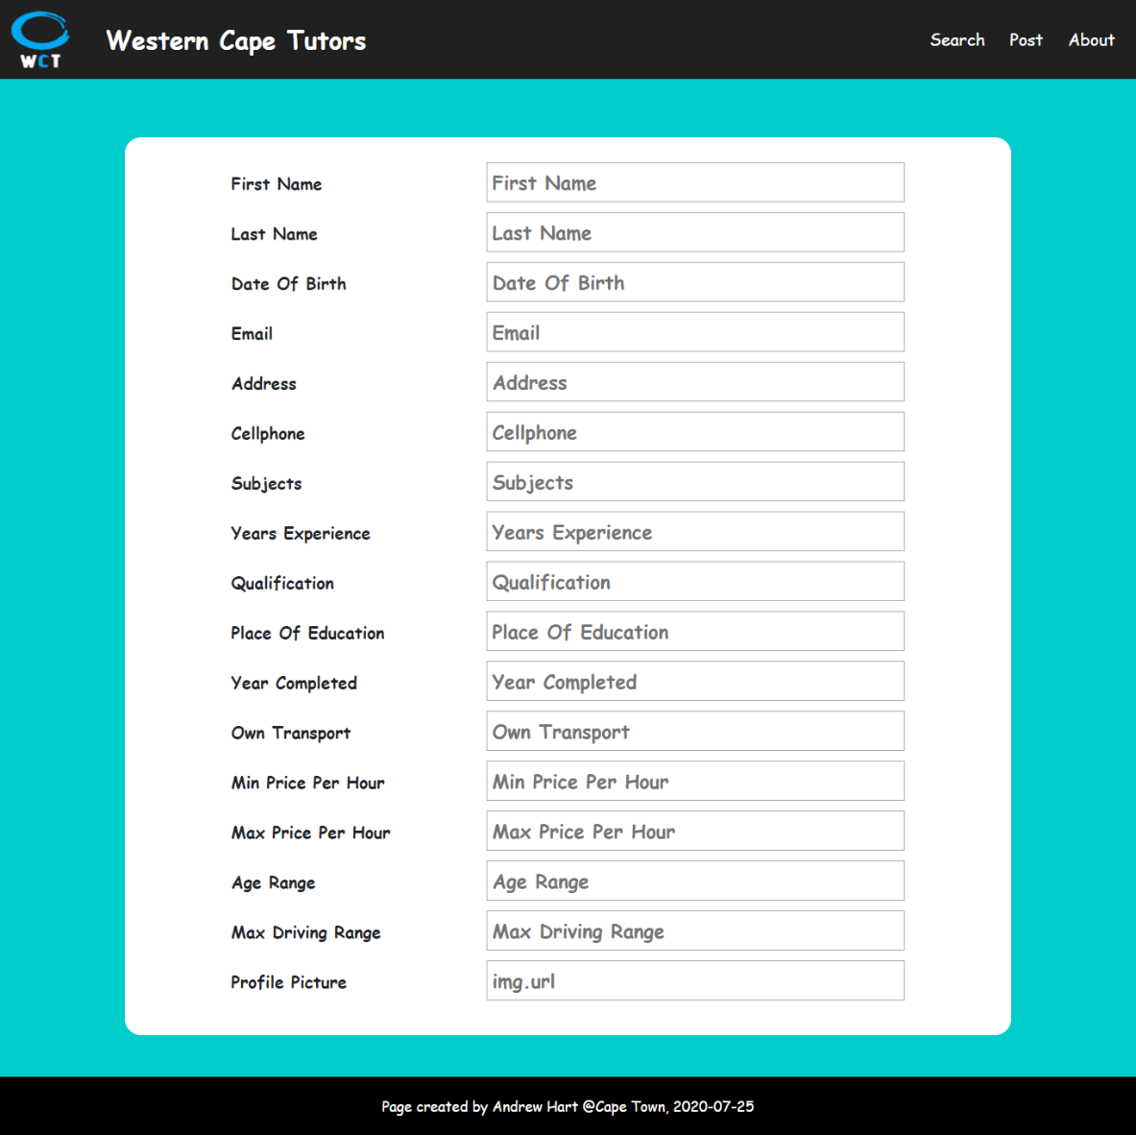



### Phone Screen Size

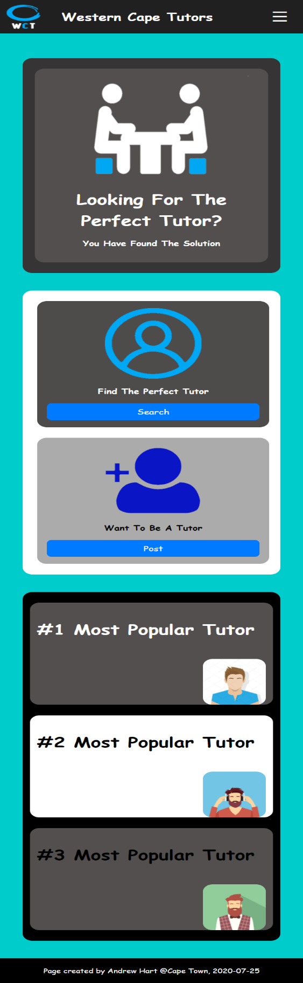

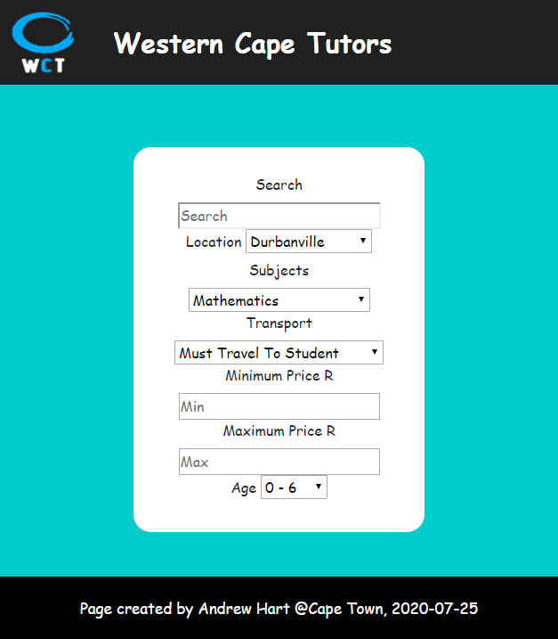

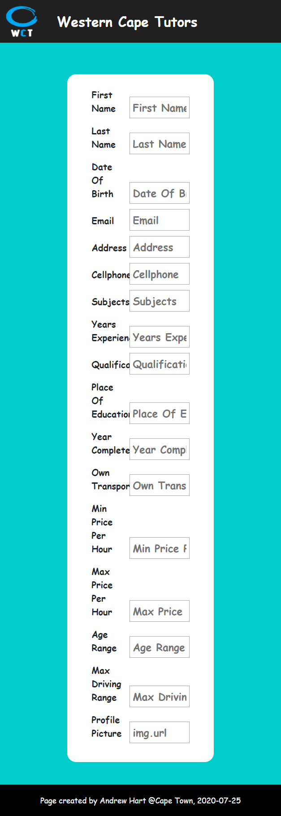

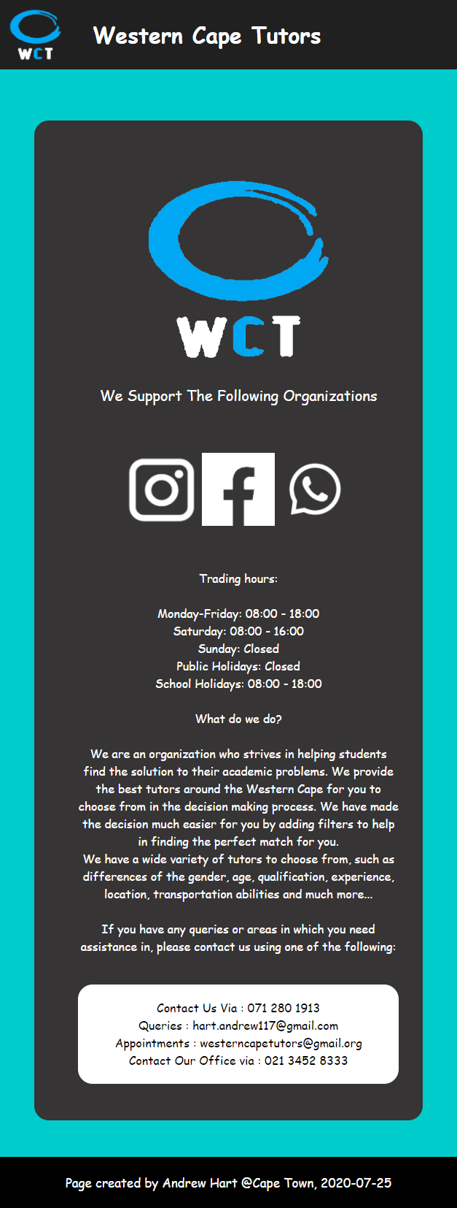

## Prototype 2

### Laptop Screen Size

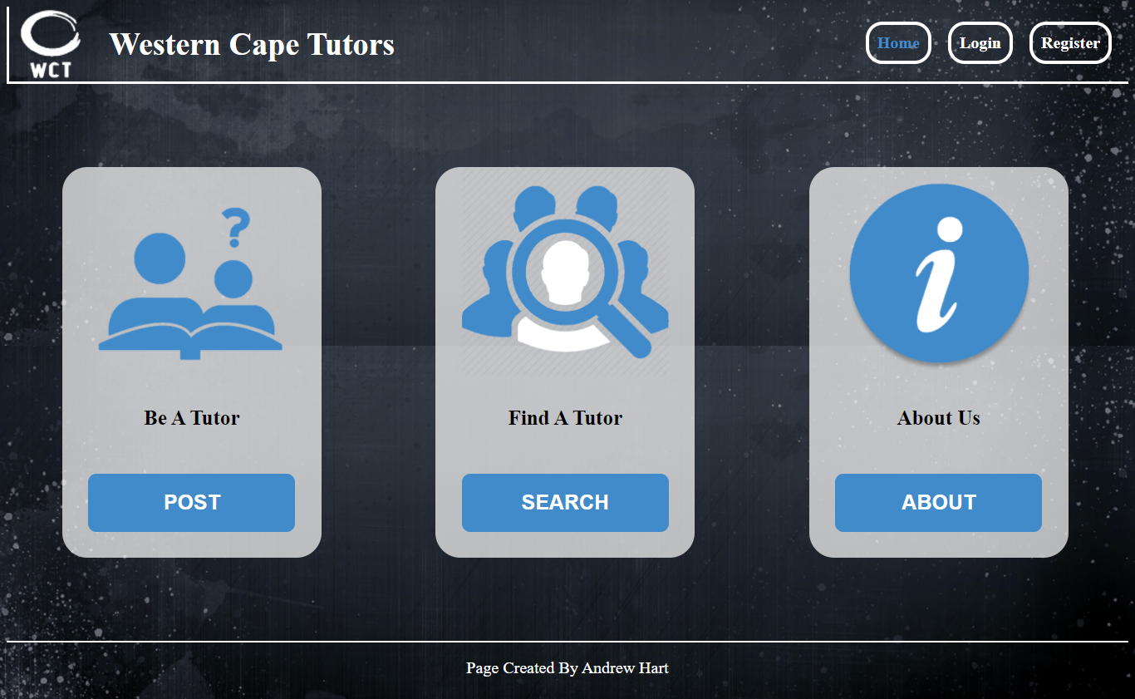

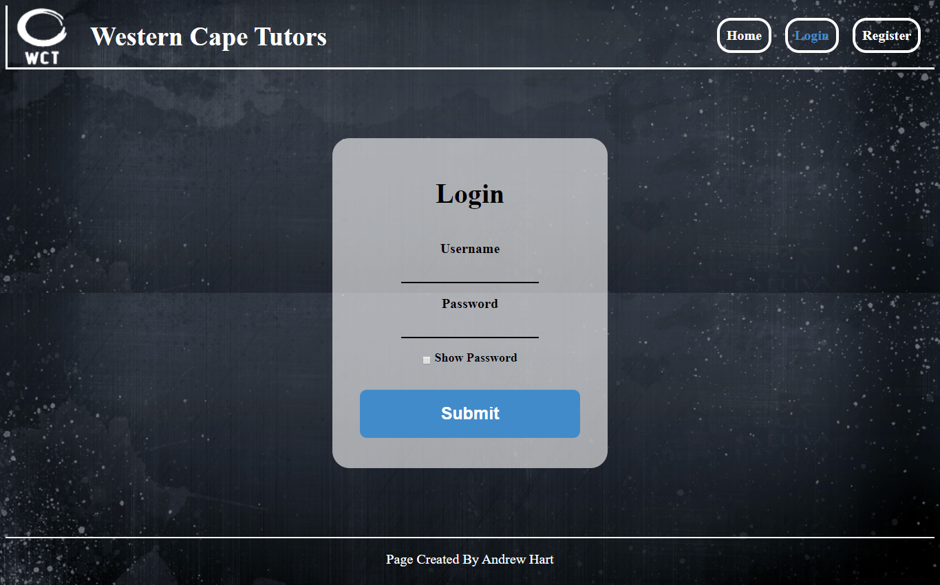

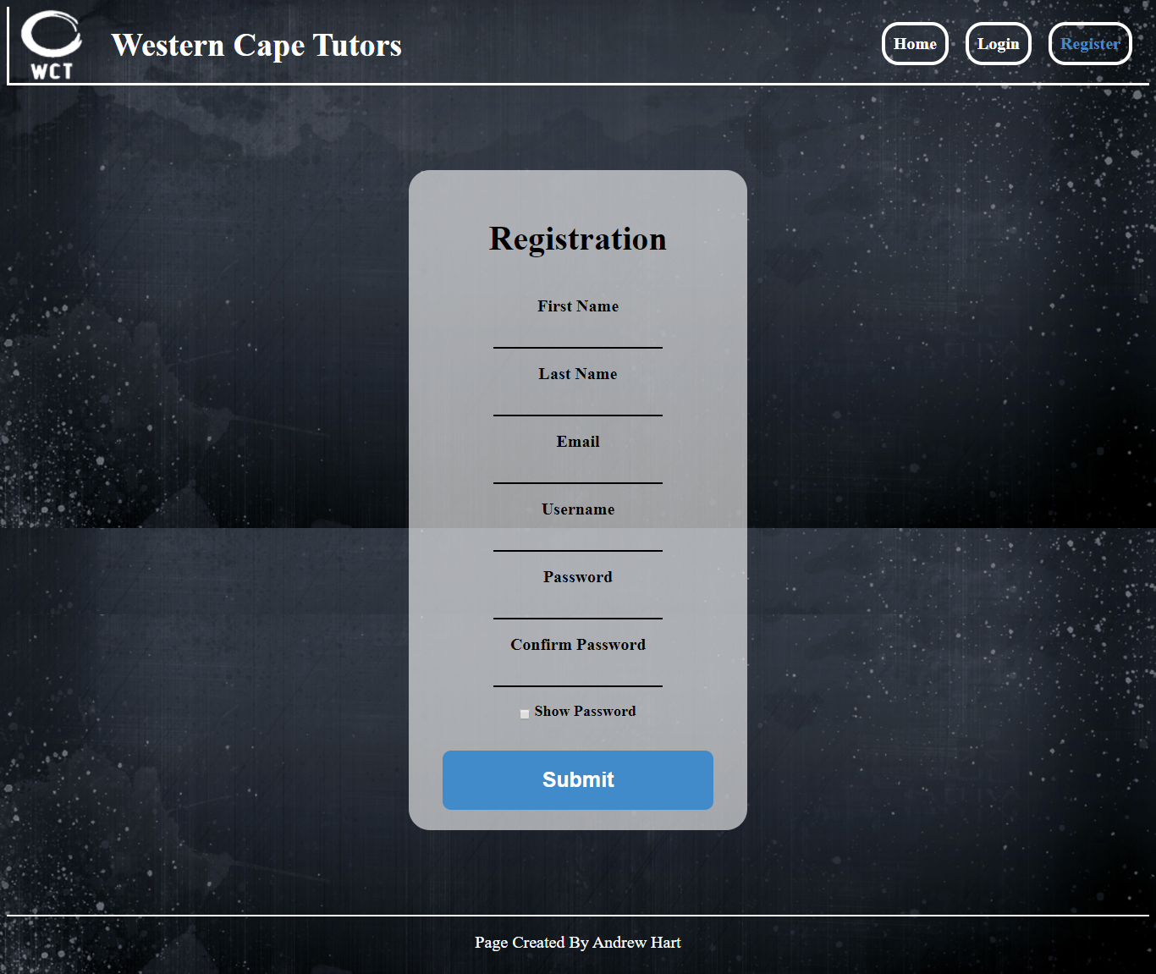



### Phone Screen Size

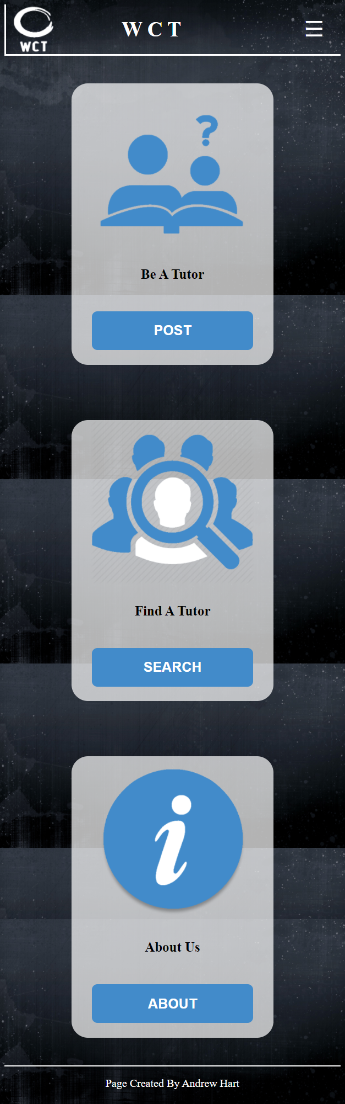

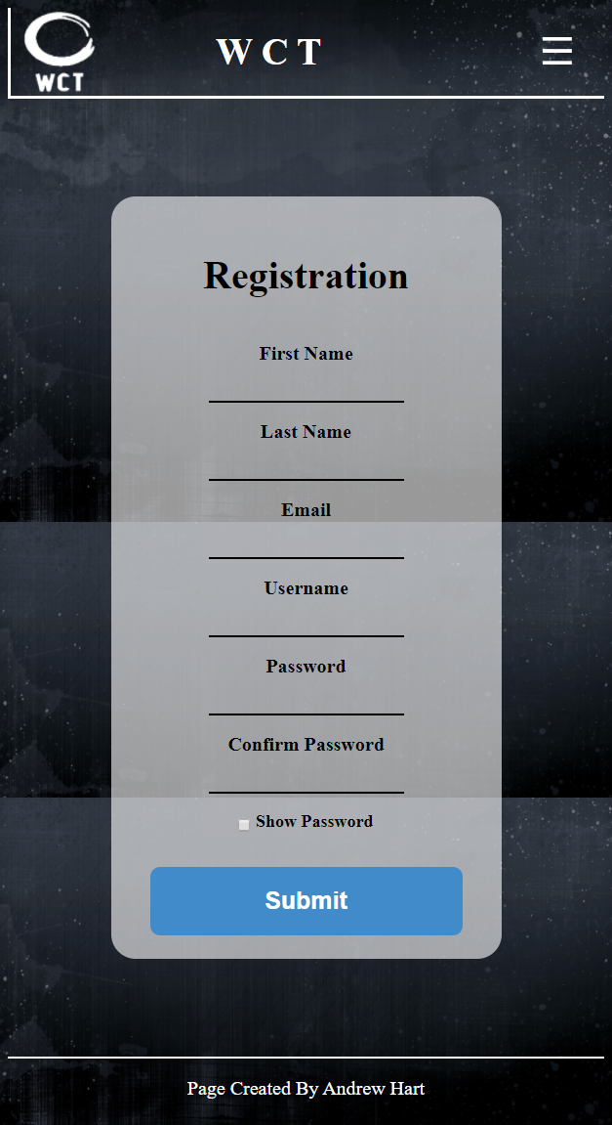

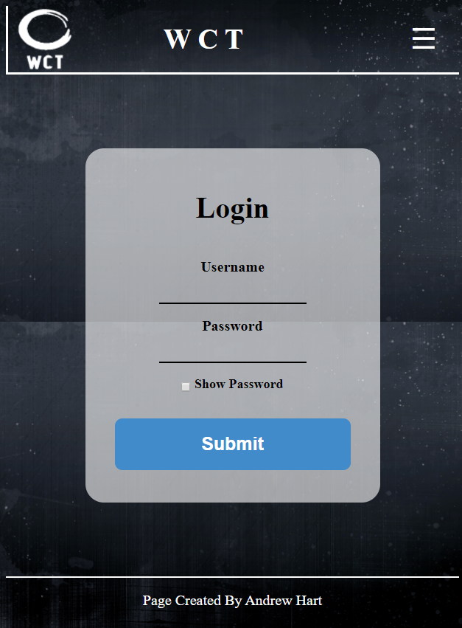

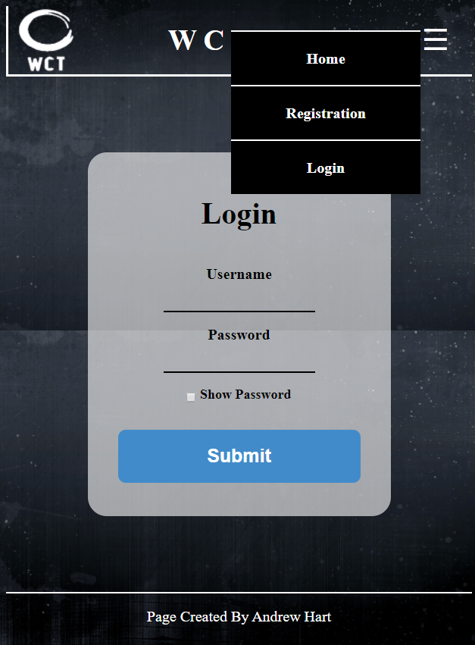

# Client Response to Prototypes

To whom it may concern,

This morning Andrew Hart presented me with two prototypes for the Western Cape Tutor application.

I was impressed by the styling of both of them, but in the end have opted for Option 1.

I particularly enjoyed the fresh styling and effects, and especially its responsiveness (mobile-friendly) when displayed on a laptop, tablet or mobile phone.

For the next phase of development, I would like to see the following functionality included:

* Any unauthenticated person must be able to Search the site
* However, a person must be authenticated (i.e. registered and logged in) in order to place a posting
* The website must have the option for changing the user’s password
* Additionally, the concept of an administrator needing to approve or reject new postings, in order to combat the inevitable flood of unwanted spam and junk
* We discussed having a "likes" indicator, although a person would probably then need to have logged-in in order to persist, so we decided against that.
* I also requested the change of background colors to something easier on the eye, to increase the look of professionalism
* We also made minor styling adjustments to improve the overall look and feel of the website

I am very optimistic about the future of this development, and look forward to seeing progress on a regular basis.

Kind Regards

B.W. Hart

0823320218

# Designing

## Class Responsibility Collaborator cards

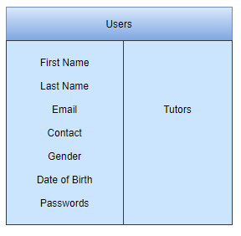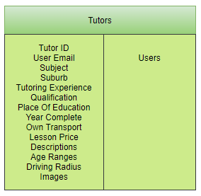

## Enhanced Entity Relationship Diagram

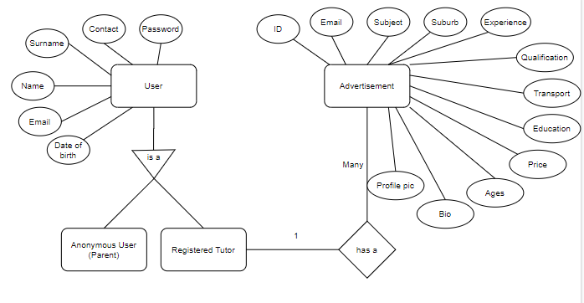

## Context Diagram

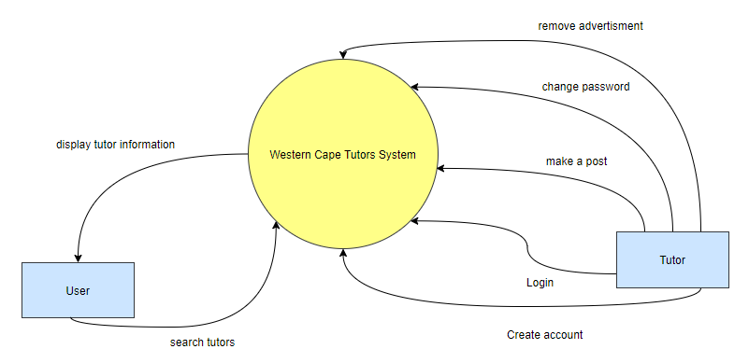

## Data Flow Diagram

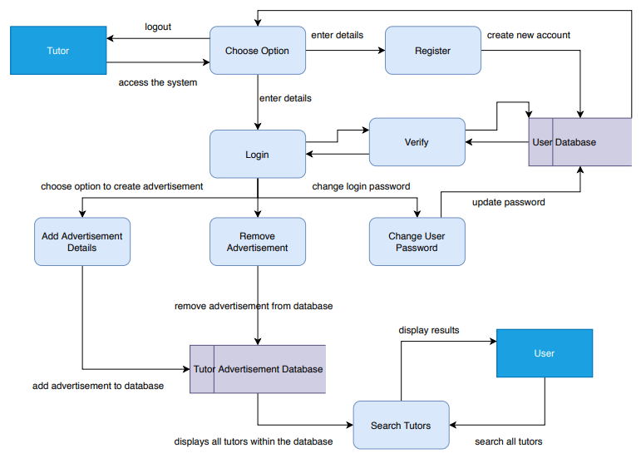

## Use Case Diagram

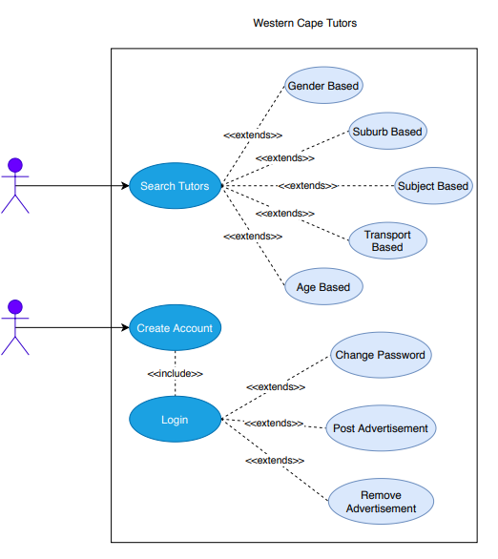

## Database Design

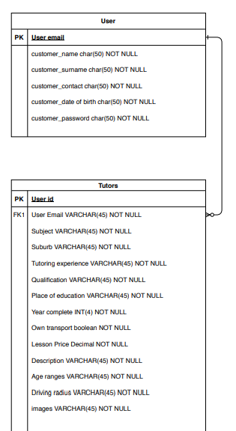

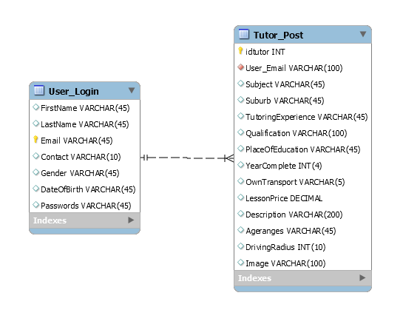

# Coding

## Screen shots

### Home Page

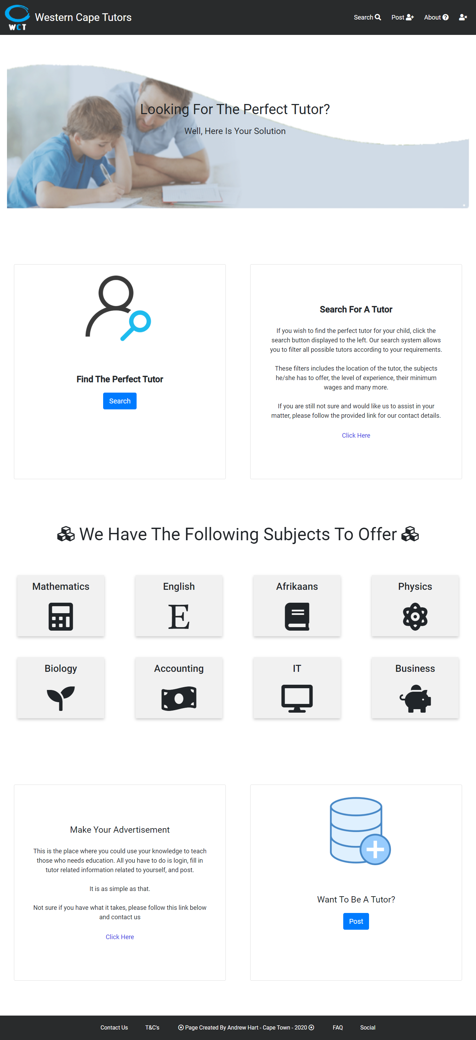

### Search Page

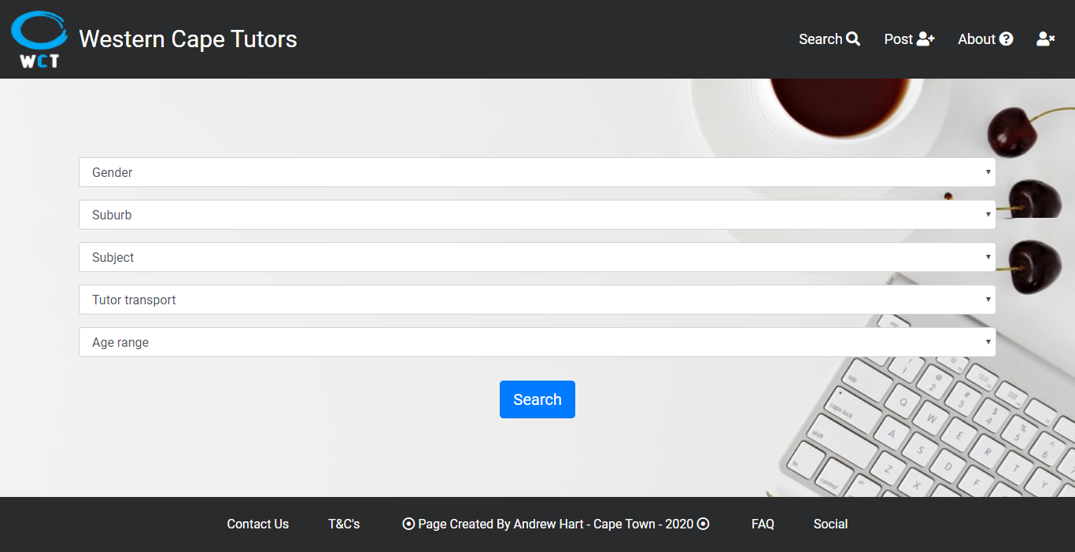

### View page

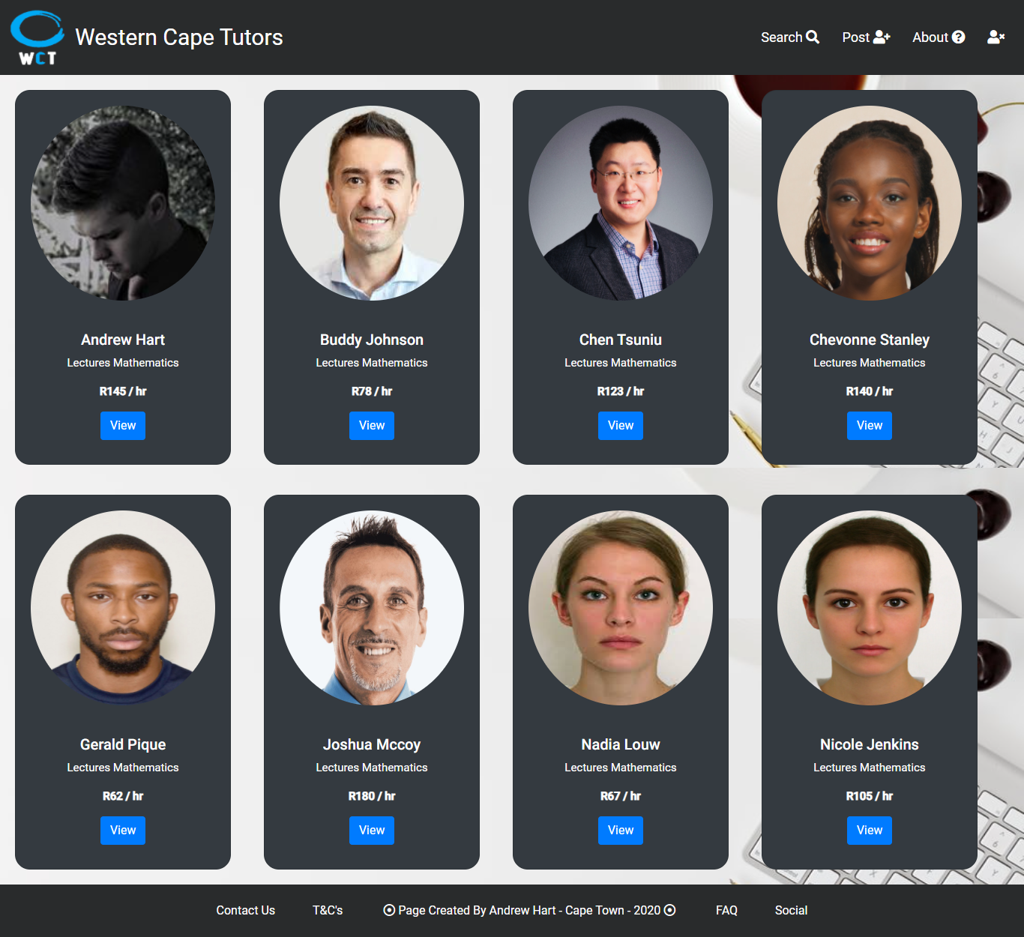

### Profile page

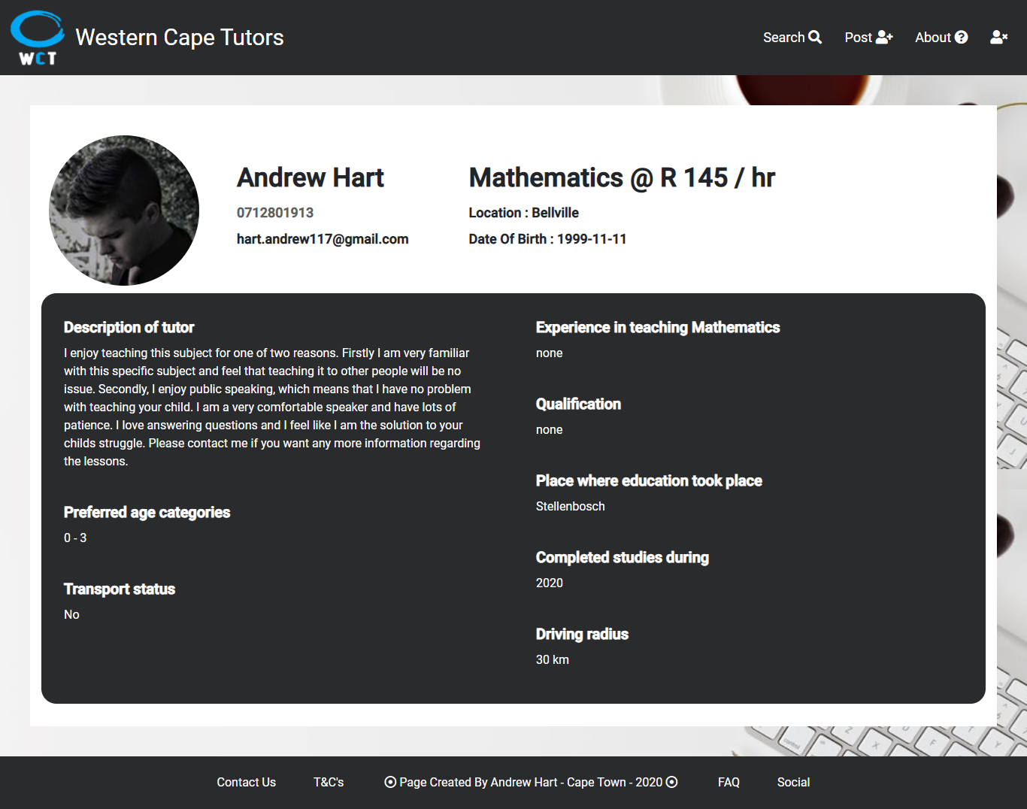

### Login/Register splash screen

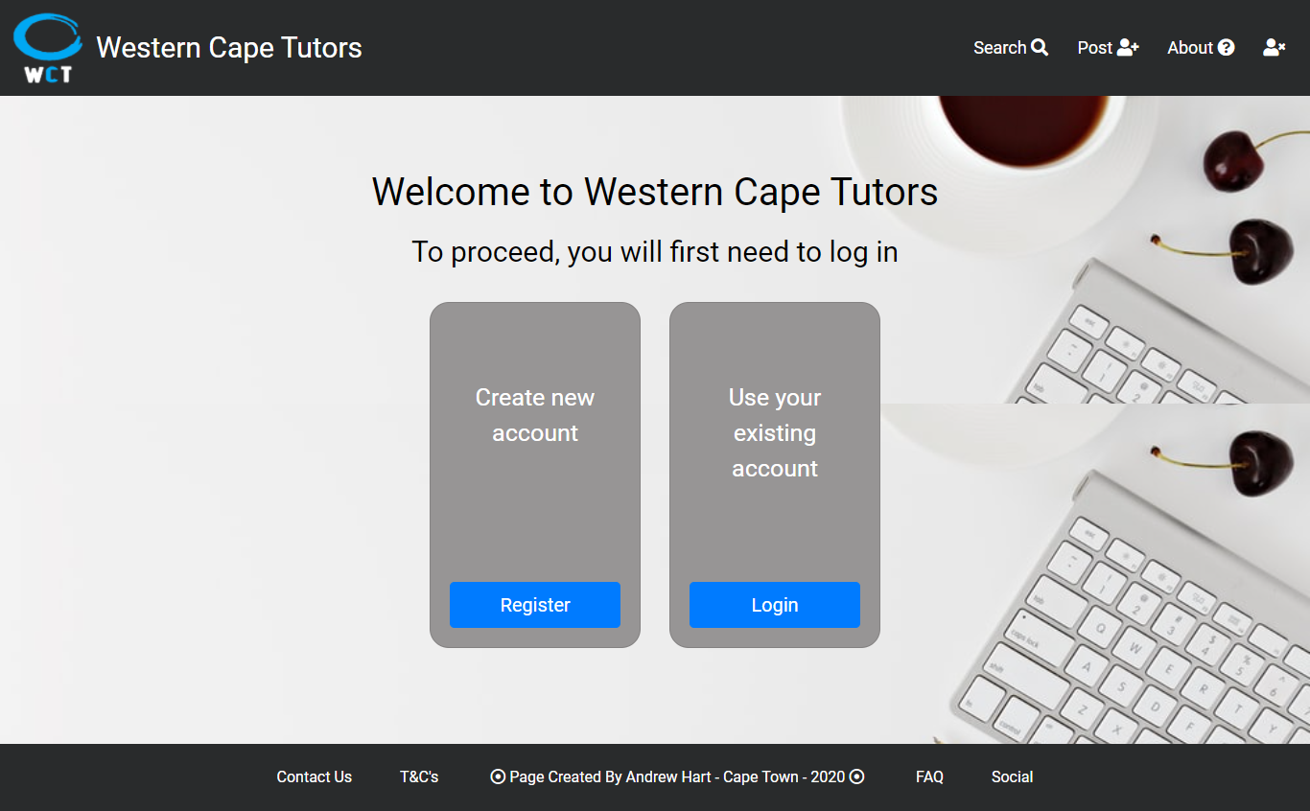

### Registration page

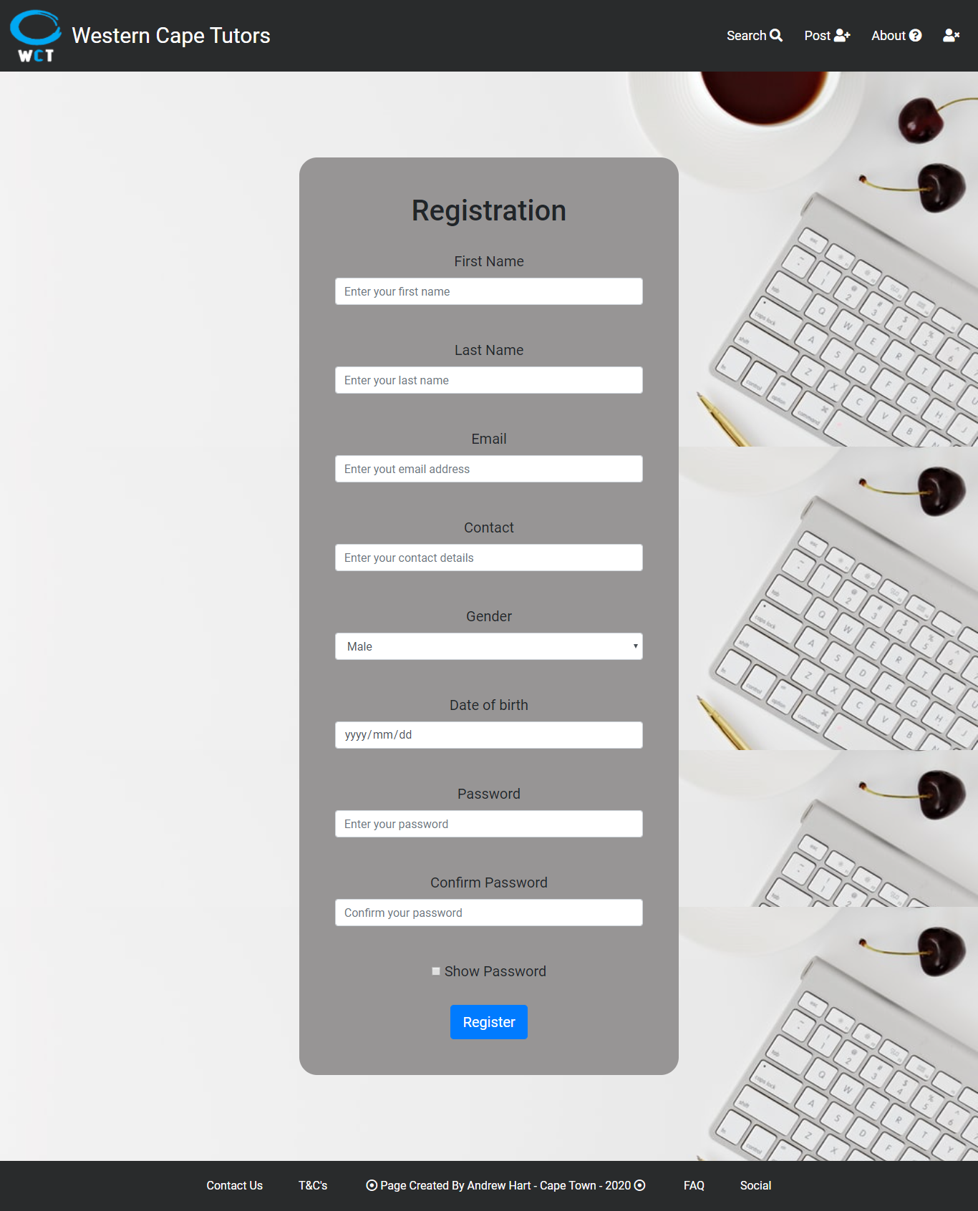

### Login page

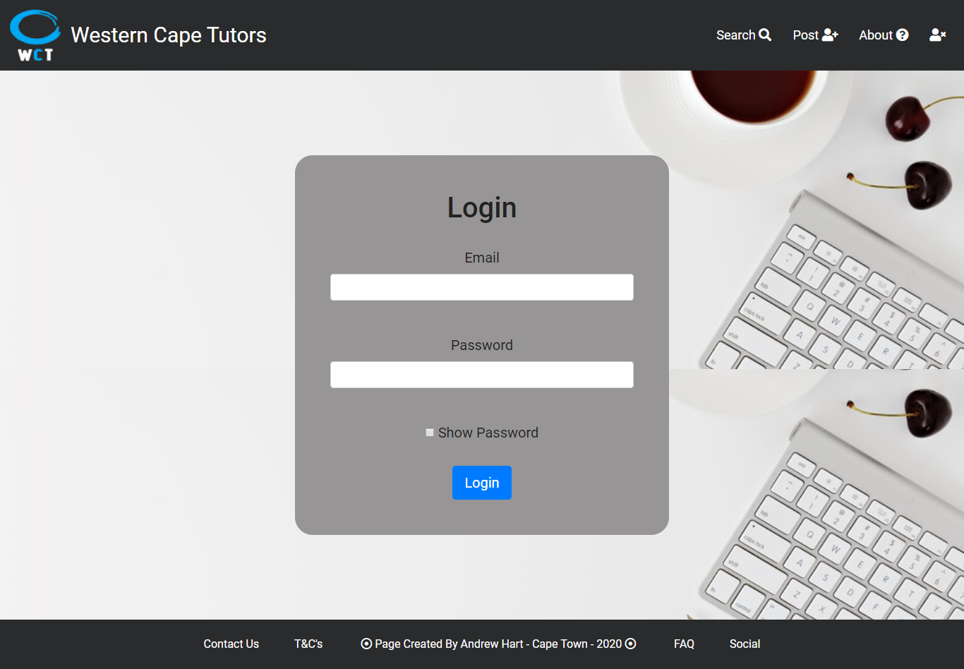

### Login success splash screen

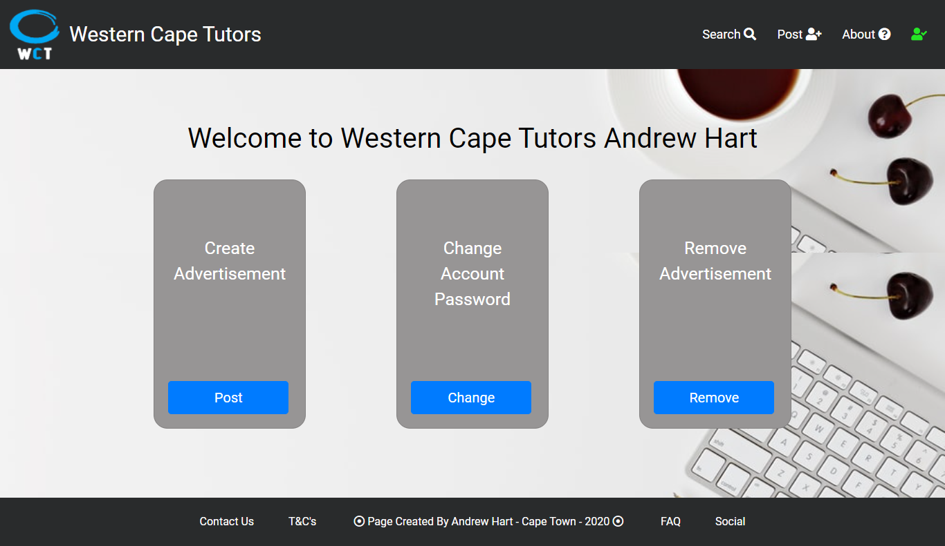

### Create advertisement page

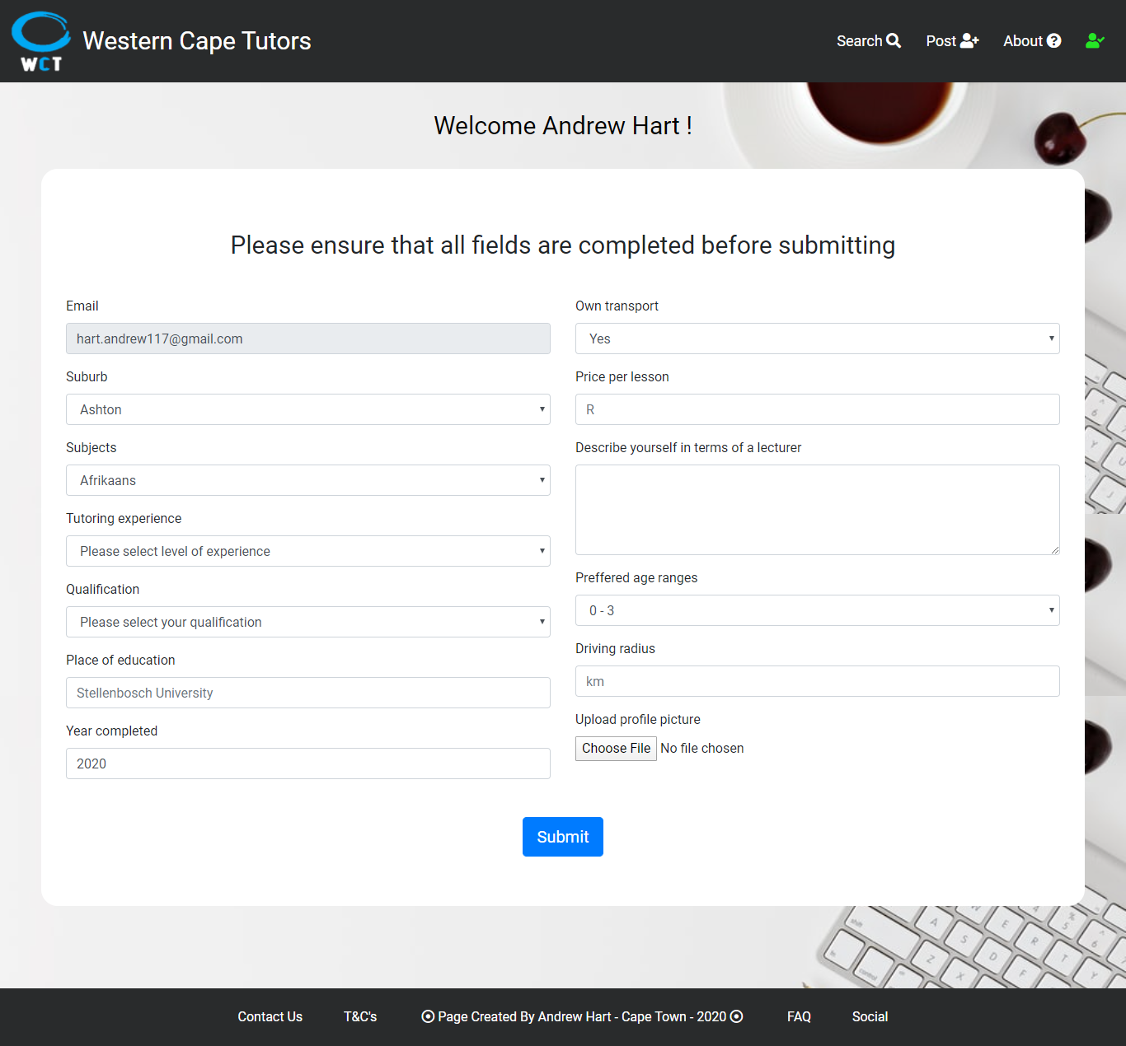

### Change password page

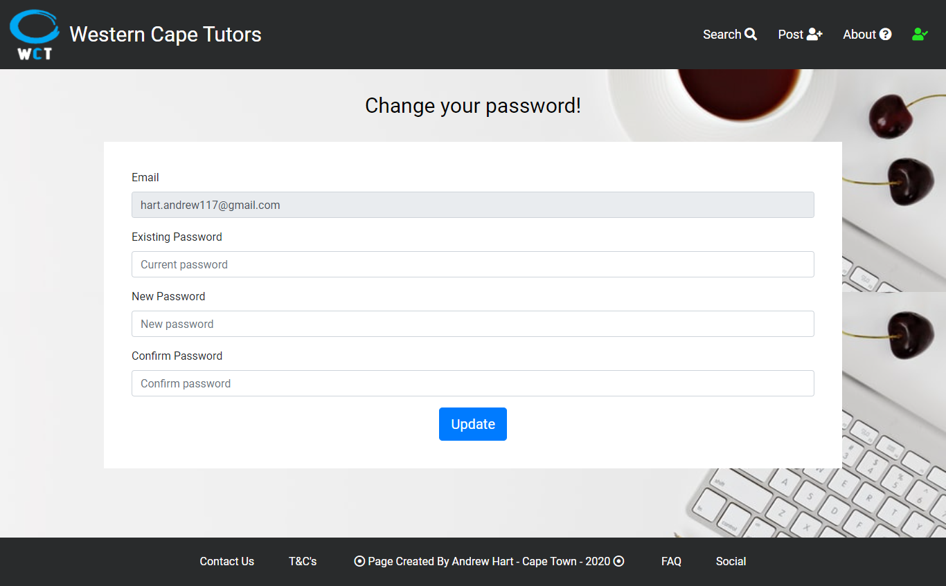

### Delete advertisement page

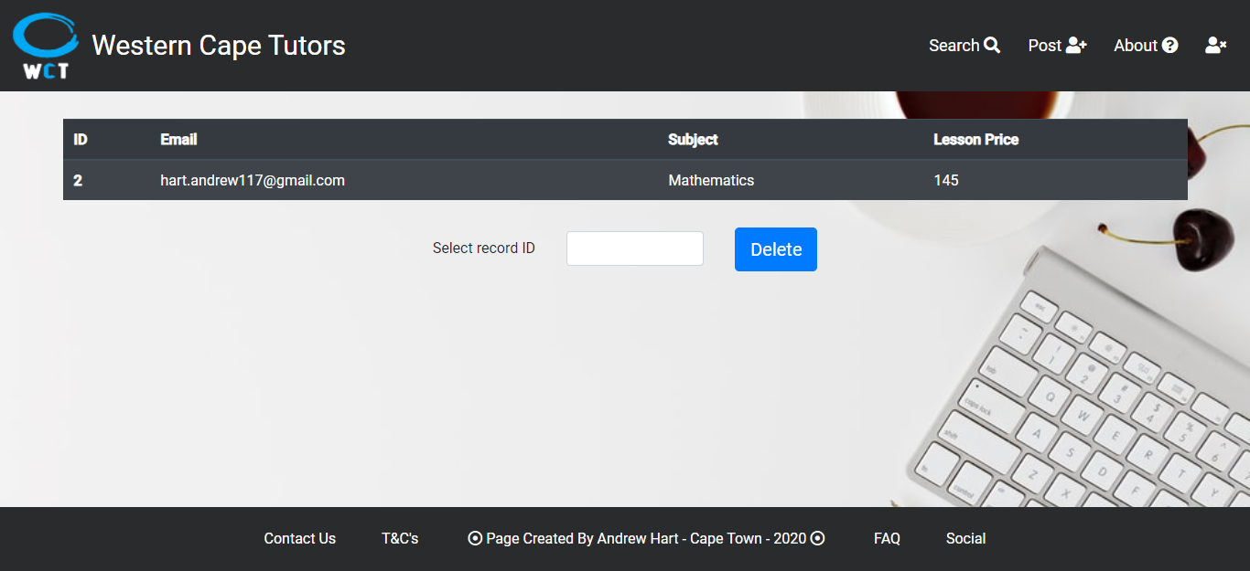

### About page part 1

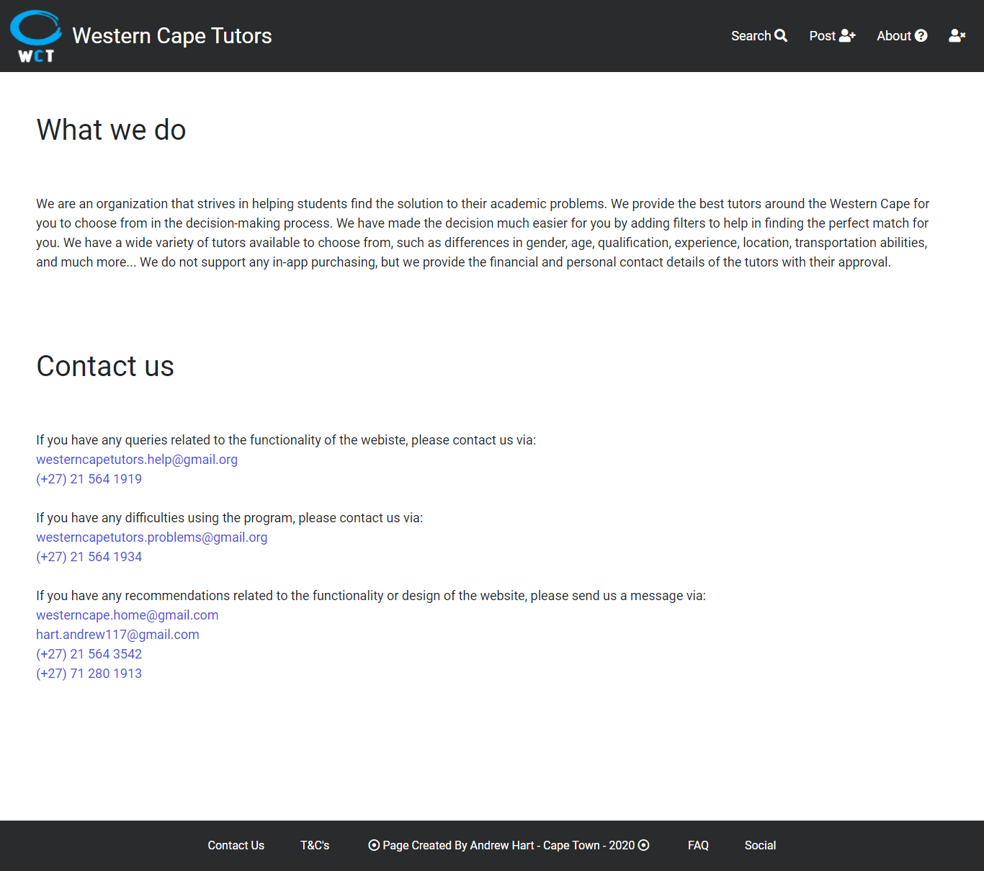

### About page part 2

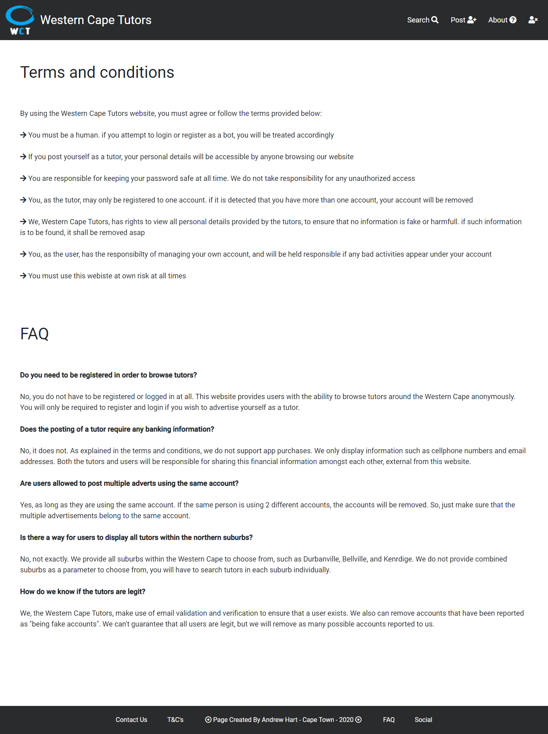

### About page part 3

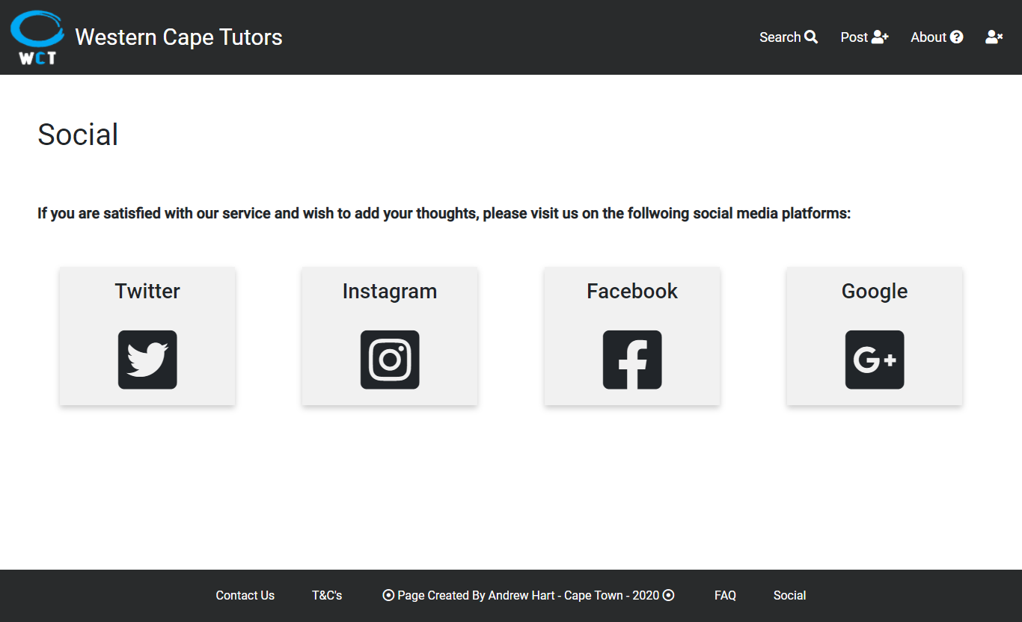

## 3 examples of my responsiveness on a iPhone x

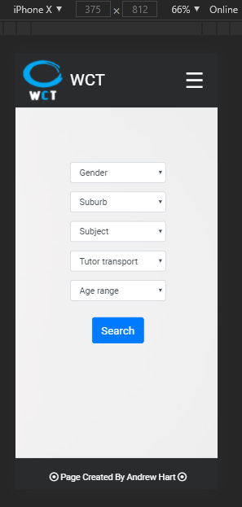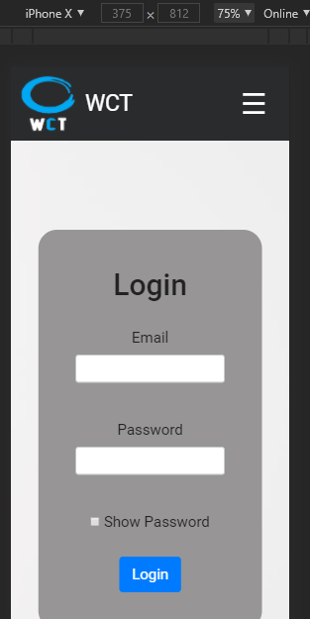

## PHP code

|  |
| --- |
| Change password php  <?php  $user = $_POST['email'];  header("Location: http://localhost/tutoring_website/final/html/change-password.html?user=" . $user);  ?> |
| Delete record php  <?php  $host = "localhost";  $user = "root";  $pass = "";  $db = "tutoring_website";  $conn = new mysqli($host, $user, $pass, $db);  if ($conn->connect_error) {      die("Connection failed: " . $conn->connect_error);  }  $id = $_POST['id-delete'];  $email = $_POST['email'];  $result = mysqli_query($conn, "select * from tutor_post where idtutor = '" . $id . "'") or die("Unable to read data");  $resultCheck = mysqli_num_rows($result);  if ($resultCheck > 0) {  $row = mysqli_fetch_assoc($result);  if ($row['User_Email'] == $email) {      $delete = mysqli_query($conn, "delete from tutor_post where idtutor = '".$id."'") or die("Unable to delete data");      header("Location: http://localhost/tutoring_website/final/html/home.html?msg=success");  }else{      header("Location: http://localhost/tutoring_website/final/html/home.html?msg=failed");  }  }else{      header("Location: http://localhost/tutoring_website/final/html/home.html?msg=failed");  }  $conn->close();  ?> |
| Login php      <?php      $host = "localhost";      $user = "root";      $pass = "";      $db = "tutoring_website";      $conn = new mysqli($host, $user, $pass, $db);      if ($conn->connect_error) {          die("Connection failed: " . $conn->connect_error);      }      $email = $_POST['email'];      $password = md5($_POST['psw']);      $result = mysqli_query($conn, "select * from user_login where Email = '" . $email . "' and Passwords = '" . $password . "'") or die("Unable to read data");      $resultCheck = mysqli_num_rows($result);      if ($resultCheck > 0) {          $rows = mysqli_fetch_assoc($result);          if (($rows['Email'] == $email) && ($rows['Passwords'] == $password)) {              $name = $rows['FirstName'];              $surname = $rows['LastName'];              header("Location: http://localhost/tutoring_website/final/html/login-dash.html?user=" . $email . "&name=" . $name . "&surname=" . $surname);          }      } else {          header("Location: http://localhost/tutoring_website/final/html/login.html");      };      $conn->close();      ?> |
| Login dash php  <?php  $user = $_POST['email'];  $name = $_POST['name'];  $surname = $_POST['surname'];  header("Location: http://localhost/tutoring_website/final/html/post.html?user=" . $user . "&name=" . $name . "&surname=" . $surname);  ?> |
| Post php  <?php  $email = $_POST['email'];  $suburb = $_POST['suburb'];  $subjects = $_POST['subjects'];  $experience = $_POST['experience'];  $qualification = $_POST['qualification'];  $education = $_POST['education'];  $complete = $_POST['complete'];  $owntransport = $_POST['owntransport'];  $price = $_POST['price'];  $bio = $_POST['bio'];  $agerange = $_POST['agerange'];  $radius = $_POST['radius'];  $profile = $_POST['profile'];  $host = "localhost";  $user = "root";  $pass = "";  $db = "tutoring_website";  // Create connection  $conn = new mysqli($host, $user, $pass, $db) or die("Unable to connect to database " + $db);  $insert = "insert into tutor_post (idtutor, User_Email, Subjects, Suburb, TutoringExperience, Qualification, PlaceOfEducation, YearComplete, OwnTransport, LessonPrice, Descriptions, Ageranges, DrivingRadius, Images) VALUES (null,'$email', '$subject', '$suburb', '$experience', '$qualification', '$education','$complete', '$owntransport', '$price', '$bio', '$agerange', '$radius', '$profile')";  $stmt = $conn->prepare($insert);  $stmt->execute();  header("Location: http://localhost/tutoring_website/final/html/search.html");  $conn->close(); |
| Register php    <?php    $fname = $_POST['fname'];    $lname = $_POST['lname'];    $email = $_POST['email'];    $contact = $_POST['cell'];    $gender = $_POST['gender'];    $dob = $_POST['dob'];    $psw = $_POST['idp'];    $cpsw = $_POST['idp2'];    $host = "localhost";    $user = "root";    $pass = "";    $db = "tutoring_website";    // Create connection    $conn = new mysqli($host, $user, $pass, $db) or die("Unable to connect to database " + $db);    $result = mysqli_query($conn, "select * from user_login where Email = '$email'");    $rows = mysqli_num_rows($result);    if ($rows > 0) {      header("Location: http://localhost/tutoring_website/final/html/registration.html");    } else {      $insert = "INSERT INTO user_login (FirstName, LastName, Email, Contact, Gender, DateOfBirth, Passwords) VALUES ('$fname', '$lname', '$email', '$contact', '$gender', '$dob', MD5('$psw'))";      $stmt = $conn->prepare($insert);      $stmt->execute();      header("Location: http://localhost/tutoring_website/final/html/splash.html");    };    $conn->close();    ?> |
| Remove advert php  <html>  <head>      <meta name="viewport" content="width=device-width, initial-scale=1.0">      <meta charset="utf-8">      <meta name="description" content="The HTML5 Herald">      <meta name="author" content="SitePoint">      <link rel="stylesheet" href="https://stackpath.bootstrapcdn.com/bootstrap/4.4.1/css/bootstrap.min.css"          integrity="sha384-Vkoo8x4CGsO3+Hhxv8T/Q5PaXtkKtu6ug5TOeNV6gBiFeWPGFN9MuhOf23Q9Ifjh" crossorigin="anonymous">      <link rel="stylesheet"          href="http://localhost/tutoring_website/final/icons/fontawesome-free-5.14.0-web/fontawesome-free-5.14.0-web/css/all.css">      <link rel="stylesheet" href="../css/design.css">  </head>  <body style="background-image: url(../icons/splash.jpg); background-size: cover; background-attachment: fixed;">      <div class="main-info">          <div class="header">              <label class="hamburger" for="link">&#9776;</label>              <input type="checkbox" id="link">              <a href="../html/home.html"><img src="../icons/logo.png" class="logo"></a>              <div class="title">Western Cape Tutors</div>              <div class="small-title">WCT</div>              <div class="menu">                  <a href="../html/search.html">Search <i class="fas fa-search"></i>                  </a>                  <a href="../html/splash.html">Post <i class="fas fa-user-plus"></i></a>                  <a href="../html/about.html">About <i class="fas fa-question-circle"></i></a>                  <a href="../html/splash.html"><i class="fas fa-user-times"></i></a>              </div>              <div class="dropdown-content">                  <a href="../html/search.html">Search</a>                  <a href="../html/splash.html">Post</a>                  <a href="../html/about.html">About</a>              </div>          </div>          <?php  $host = "localhost";  $user = "root";  $pass = "";  $db = "tutoring_website";  $conn = new mysqli($host, $user, $pass, $db);  if ($conn->connect_error) {      die("Connection failed: " . $conn->connect_error);  }  $email = $_POST['email'];  $result = mysqli_query($conn, "select * from tutor_post where tutor_post.User_Email = '".$email."'") or die("Unable to read data");  $resultCheck = mysqli_num_rows($result);  if ($resultCheck > 0) {      ?>          <table class="table table-striped table-dark" style="width: 90%; margin : 30px auto 0 auto">              <thead>                  <tr>                      <th scope="col">ID</th>                      <th scope="col">Email</th>                      <th scope="col">Subject</th>                      <th scope="col">Lesson Price</th>                  </tr>              </thead>              <tbody>                  <?php      while ($row = $result->fetch_assoc()) {  ?>                  <tr>                      <th scope="row"><?php echo $row['idtutor'] ?></th>                      <td><?php echo $row['User_Email'] ?></td>                      <td><?php echo $row['Subjects'] ?></td>                      <td><?php echo $row['LessonPrice'] ?></td>                  </tr>                  <?php      }      ?>              </tbody>          </table>          <form class="form-delete-record" action="delete-record.php" method="POST">              <label for="id-delete">Select record ID</label>              <input type="number" name="id-delete" id="id-delete" class="form-control">              <input type="text" name="email" id="email" style="display : none" value="<?php echo $email ?>">              <button type="submit" class="btn btn-primary btn-lg" style="display : inline-block">Delete</button>          </form>          <?php  } else {      ?>          <div class="error-response">              No records found!          </div>          <?php                  }  $conn->close();  ?>        </div>      <div class="footer">          <a href="../html/about.html #contact-division" class="footer-buttons-left">Contact Us</a><a              href="../html/about.html #terms-division" class="footer-buttons-left">T&C's</a>          <i class="far fa-dot-circle"></i> Page Created By Andrew Hart - Cape Town - 2020 <i              class="far fa-dot-circle"></i>          <a href="../html/about.html #faq-division" class="footer-buttons-right">FAQ</a><a              href="../html/about.html #social-division" class="footer-buttons-right">Social</a>      </div>      <div class="small-footer">          <i class="far fa-dot-circle"></i> Page Created By Andrew Hart - Cape Town - 2020 <i              class="far fa-dot-circle"></i>      </div>      <div class="super-small-footer">          <i class="far fa-dot-circle"></i> Page Created By Andrew Hart <i class="far fa-dot-circle"></i>      </div>  </body>  </html> |
| Search php      <html>      <head>          <meta name="viewport" content="width=device-width, initial-scale=1.0">          <meta charset="utf-8">          <meta name="description" content="The HTML5 Herald">          <meta name="author" content="SitePoint">          <link rel="stylesheet" href="https://stackpath.bootstrapcdn.com/bootstrap/4.4.1/css/bootstrap.min.css"              integrity="sha384-Vkoo8x4CGsO3+Hhxv8T/Q5PaXtkKtu6ug5TOeNV6gBiFeWPGFN9MuhOf23Q9Ifjh" crossorigin="anonymous">          <link rel="stylesheet"              href="http://localhost/tutoring_website/final/icons/fontawesome-free-5.14.0-web/fontawesome-free-5.14.0-web/css/all.css">          <link rel="stylesheet" href="../css/design.css">      </head>      <body style="background-image: url(../icons/splash.jpg); background-size: cover; background-attachment: fixed;">          <div class="main-info">              <div class="header">                  <label class="hamburger" for="link">&#9776;</label>                  <input type="checkbox" id="link">                  <a href="../html/home.html"><img src="../icons/logo.png" class="logo"></a>                  <div class="title">Western Cape Tutors</div>                  <div class="small-title">WCT</div>                  <div class="menu">                      <a href="../html/search.html">Search <i class="fas fa-search"></i>                      </a>                      <a href="../html/splash.html">Post <i class="fas fa-user-plus"></i></a>                      <a href="../html/about.html">About <i class="fas fa-question-circle"></i></a>                      <a href="../html/splash.html"><i class="fas fa-user-times"></i></a>                  </div>                  <div class="dropdown-content">                      <a href="../html/search.html">Search</a>                      <a href="../html/splash.html">Post</a>                      <a href="../html/about.html">About</a>                  </div>              </div>              <?php              $host = "localhost";              $user = "root";              $pass = "";              $db = "tutoring_website";              $conn = new mysqli($host, $user, $pass, $db);              if ($conn->connect_error) {                  die("Connection failed: " . $conn->connect_error);              }              $gender = $_POST['gender'];              $suburb = $_POST['suburb'];              $subject = $_POST['subject'];              $transport = $_POST['owntransport'];              $age = $_POST['agerange'];              $result = mysqli_query($conn, "select * from tutor_post, user_login where tutor_post.User_Email = user_login.Email and user_login.Gender " . $gender . " and tutor_post.Suburb " . $suburb . " and tutor_post.Subjects " . $subject . " and tutor_post.OwnTransport " . $transport . " and tutor_post.Ageranges " . $age . "") or die("Unable to read data");              $resultCheck = mysqli_num_rows($result);              if ($resultCheck > 0) {                  while ($row = $result->fetch_assoc()) {              ?>              <div class="card text-white bg-dark" id="tutor-card">                  <img class="tutor-img" src="../images/<?php echo $row['Images'] ?>" alt="Card image cap">                  <div class="tutor-body">                      <h5 class="tutor-name"><?php echo $row['FirstName'] . " " . $row['LastName'] ?></h5>                      <p class="tutor-subject">Lectures <?php echo $row['Subjects'] ?></p>                      <p class="tutor-price">R<?php echo $row['LessonPrice'] ?> / hr</p>                      <form action="../php/view.php" method="POST">                          <input name="id-record" type="text" value="<?php echo $row['idtutor'] ?>"                              style="display: none;">                          <button type="submit" class="btn btn-primary">View</button>                      </form>                  </div>              </div>              <?php                  }              } else {                  ?>              <div class="error-response">                  No records found!              </div>              <?php              }              $conn->close();              ?>          </div>          <div class="footer">              <a href="../html/about.html #contact-division" class="footer-buttons-left">Contact Us</a><a                  href="../html/about.html #terms-division" class="footer-buttons-left">T&C's</a>              <i class="far fa-dot-circle"></i> Page Created By Andrew Hart - Cape Town - 2020 <i                  class="far fa-dot-circle"></i>              <a href="../html/about.html #faq-division" class="footer-buttons-right">FAQ</a><a                  href="../html/about.html #social-division" class="footer-buttons-right">Social</a>          </div>          <div class="small-footer">              <i class="far fa-dot-circle"></i> Page Created By Andrew Hart - Cape Town - 2020 <i                  class="far fa-dot-circle"></i>          </div>          <div class="super-small-footer">              <i class="far fa-dot-circle"></i> Page Created By Andrew Hart <i class="far fa-dot-circle"></i>          </div>      </body>      </html> |
| Update password php  <?php  $host = "localhost";  $user = "root";  $pass = "";  $db = "tutoring_website";  $conn = new mysqli($host, $user, $pass, $db);  if ($conn->connect_error) {      die("Connection failed: " . $conn->connect_error);  }  $email = $_POST['email'];  $password = md5($_POST['epsw']);  $updatedpassword = md5($_POST['npsw']);  $result = mysqli_query($conn, "select * from user_login where Email = '" . $email . "' and Passwords = '" . $password . "'") or die("Unable to read data");  $resultCheck = mysqli_num_rows($result);  if ($resultCheck > 0) {      $rows = mysqli_fetch_assoc($result);      if (($rows['Email'] == $email) && ($rows['Passwords'] == $password)) {          $update = mysqli_query($conn, "update user_login set user_login.Passwords = '" . $updatedpassword . "' WHERE user_login.Email = '" . $email . "'") or die("Unable to read data");          header("Location: http://localhost/tutoring_website/final/html/splash.html");      } else {          header("Location: http://localhost/tutoring_website/final/html/change-password.html");      }  }  $conn->close(); |
| View php  <html>  <head>      <meta name="viewport" content="width=device-width, initial-scale=1.0">      <meta charset="utf-8">      <meta name="description" content="The HTML5 Herald">      <meta name="author" content="SitePoint">      <link rel="stylesheet" href="https://stackpath.bootstrapcdn.com/bootstrap/4.4.1/css/bootstrap.min.css"          integrity="sha384-Vkoo8x4CGsO3+Hhxv8T/Q5PaXtkKtu6ug5TOeNV6gBiFeWPGFN9MuhOf23Q9Ifjh" crossorigin="anonymous">      <link rel="stylesheet"          href="http://localhost/tutoring_website/final/icons/fontawesome-free-5.14.0-web/fontawesome-free-5.14.0-web/css/all.css">      <link rel="stylesheet" href="../css/design.css">  </head>  <body style="background-image: url(../icons/splash.jpg); background-size: cover; background-attachment: fixed;">      <div class="main-info">          <div class="header">              <label class="hamburger" for="link">&#9776;</label>              <input type="checkbox" id="link">              <a href="../html/home.html"><img src="../icons/logo.png" class="logo"></a>              <div class="title">Western Cape Tutors</div>              <div class="small-title">WCT</div>              <div class="menu">                  <a href="../html/search.html">Search <i class="fas fa-search"></i>                  </a>                  <a href="../html/splash.html">Post <i class="fas fa-user-plus"></i></a>                  <a href="../html/about.html">About <i class="fas fa-question-circle"></i></a>                  <a href="../html/splash.html"><i class="fas fa-user-times"></i></a>              </div>              <div class="dropdown-content">                  <a href="../html/search.html">Search</a>                  <a href="../html/splash.html">Post</a>                  <a href="../html/about.html">About</a>              </div>          </div>          <?php          $host = "localhost";          $user = "root";          $pass = "";          $db = "tutoring_website";          $id = $_POST['id-record'];          $conn = new mysqli($host, $user, $pass, $db);          if ($conn->connect_error) {              die("Connection failed: " . $conn->connect_error);          }          $result = mysqli_query($conn, "select * from tutor_post, user_login where tutor_post.idtutor = $id AND tutor_post.User_Email = user_login.Email") or die("Unable to read data");          $resultCheck = mysqli_num_rows($result);          if ($resultCheck > 0) {              while ($row = $result->fetch_assoc()) {          ?>          <div class="tutor-display">              <div class="row">                  <div class="tutor-display-left">                      <img class="tutor-display-image" src="../images/<?php echo $row['Images'] ?>" alt="">                  </div>                  <div class="tutor-display-right">                      <div class="info">                          <label                              class="label-tutor-heading"><?php echo $row['FirstName'] . " " . $row['LastName'] ?></label><br>                          <label class="label-tutor-cell"><?php echo $row['Contact'] ?></label><br>                          <label class="label-info"><?php echo $row['User_Email'] ?></label><br>                      </div>                  </div>                  <div class="info-2">                      <label class="label-tutor-heading"><?php echo $row['Subjects'] ?> @ R                          <?php echo $row['LessonPrice'] ?> / hr</label><br>                      <label class="label-info">Location : <?php echo $row['Suburb'] ?></label><br>                      <label class="label-info">Date Of Birth : <?php echo $row['DateOfBirth'] ?></label><br>                  </div>              </div>              <div class="row" style="background-color : #292b2c; border-radius : 20px;">                  <div class="col-sm" id="bottom">                      <label class="column-heading">Description of tutor</label><br>                      <p><?php echo $row['Descriptions'] ?></p><br>                      <label class="column-heading">Preferred age categories</label><br>                      <p><?php echo $row['Ageranges'] ?> </p><br>                      <label class="column-heading">Transport status</label><br>                      <p><?php echo $row['OwnTransport'] ?></p>                  </div>                  <div class="col-sm" id="bottom">                      <label class="column-heading">Experience in teaching <?php echo $row['Subjects'] ?></label><br>                      <p><?php echo $row['TutoringExperience'] ?></p><br>                      <label class="column-heading">Qualification</label><br>                      <p><?php echo $row['Qualification'] ?></p><br>                      <label class="column-heading">Place where education took place</label><br>                      <p><?php echo $row['PlaceOfEducation'] ?></p><br>                      <label class="column-heading">Completed studies during</label><br>                      <p><?php echo $row['YearComplete'] ?></p><br>                      <label class="column-heading">Driving radius</label>                      <p> <?php echo $row['DrivingRadius'] ?> km</p>                  </div>              </div>          </div>          <?php              }          } else {              echo "Error";          }          $conn->close();          ?>      </div>      <div class="footer">          <a href="../html/about.html #contact-division" class="footer-buttons-left">Contact Us</a><a              href="../html/about.html #terms-division" class="footer-buttons-left">T&C's</a>          <i class="far fa-dot-circle"></i> Page Created By Andrew Hart - Cape Town - 2020 <i              class="far fa-dot-circle"></i>          <a href="../html/about.html #faq-division" class="footer-buttons-right">FAQ</a><a              href="../html/about.html #social-division" class="footer-buttons-right">Social</a>      </div>      <div class="small-footer">          <i class="far fa-dot-circle"></i> Page Created By Andrew Hart - Cape Town - 2020 <i              class="far fa-dot-circle"></i>      </div>      <div class="super-small-footer">          <i class="far fa-dot-circle"></i> Page Created By Andrew Hart <i class="far fa-dot-circle"></i>      </div>  </body>  </html> |

## HTML code

|  |
| --- |
| About html  <!doctype html>  <html lang="en">  <head>      <meta name="viewport" content="width=device-width, initial-scale=1.0">      <meta charset="utf-8">      <meta name="description" content="The HTML5 Herald">      <meta name="author" content="SitePoint">      <link rel="stylesheet" href="https://stackpath.bootstrapcdn.com/bootstrap/4.4.1/css/bootstrap.min.css" integrity="sha384-Vkoo8x4CGsO3+Hhxv8T/Q5PaXtkKtu6ug5TOeNV6gBiFeWPGFN9MuhOf23Q9Ifjh" crossorigin="anonymous">      <link rel="stylesheet" href="http://localhost/tutoring_website/final/icons/fontawesome-free-5.14.0-web/fontawesome-free-5.14.0-web/css/all.css">      <link rel="stylesheet" href="../css/design.css">  </head>  <body>      <div class="main-info">          <div class="header">              <label class="hamburger" for="link">&#9776;</label>              <input type="checkbox" id="link">              <a href="home.html"><img src="../icons/logo.png" class="logo"></a>              <div class="title">Western Cape Tutors</div>              <div class="small-title">WCT</div>              <div class="menu">                  <a href="search.html">Search  <i class="fas fa-search"></i>                  </a>                  <a href="splash.html">Post  <i class="fas fa-user-plus"></i></a>                  <a href="about.html">About  <i class="fas fa-question-circle"></i></a>                  <a href="splash.html"><i class="fas fa-user-times"></i></a>              </div>              <div class="dropdown-content">                  <a href="search.html">Search</a>                  <a href="splash.html">Post</a>                  <a href="about.html">About</a>              </div>          </div>          <div class="panel">              <div class="card h-100" id="about-cards">                  <div class="about-titles" id="about-division">                      What we do                  </div>                  <div class="about-cards-body">                      We are an organization that strives in helping students find the solution to their academic problems. We provide the best tutors around the Western Cape for you to choose from in the decision-making process. We have made the decision much easier for you                      by adding filters to help in finding the perfect match for you. We have a wide variety of tutors available to choose from, such as differences in gender, age, qualification, experience, location, transportation abilities, and much                      more... We do not support any in-app purchasing, but we provide the financial and personal contact details of the tutors with their approval.                  </div>              </div>              <div class="card h-100" id="about-cards">                  <div class="about-titles" id="contact-division">                      Contact us                  </div>                  <div class="about-cards-body">                      If you have any queries related to the functionality of the webiste, please contact us via: <br>                      <div class="contacts">westerncapetutors.help@gmail.org<br>(+27) 21 564 1919</div>                      <br> If you have any difficulties using the program, please contact us via:<br>                      <div class="contacts">westerncapetutors.problems@gmail.org<br>(+27) 21 564 1934</div>                      <br> If you have any recommendations related to the functionality or design of the website, please send us a message via:<br>                      <div class="contacts">westerncape.home@gmail.com<br>hart.andrew117@gmail.com<br>(+27) 21 564 3542<br>(+27) 71 280 1913</div>                  </div>              </div>              <div class="card h-100" id="about-cards">                  <div class="about-titles" id="terms-division">                      Terms and conditions                  </div>                  <div class="about-cards-body">                      By using the Western Cape Tutors website, you must agree or follow the terms provided below:                      <br><br>                      <i class="fas fa-arrow-right"></i> You must be a human. if you attempt to login or register as a bot, you will be treated accordingly<br><br>                      <i class="fas fa-arrow-right"></i> If you post yourself as a tutor, your personal details will be accessible by anyone browsing our website<br><br>                      <i class="fas fa-arrow-right"></i> You are responsible for keeping your password safe at all time. We do not take responsibility for any unauthorized access<br><br>                      <i class="fas fa-arrow-right"></i> You, as the tutor, may only be registered to one account. if it is detected that you have more than one account, your account will be removed<br><br>                      <i class="fas fa-arrow-right"></i> We, Western Cape Tutors, has rights to view all personal details provided by the tutors, to ensure that no information is fake or harmfull. if such information is to be found, it shall be removed                      asap                      <br><br>                      <i class="fas fa-arrow-right"></i> You, as the user, has the responsibilty of managing your own account, and will be held responsible if any bad activities appear under your account <br><br>                      <i class="fas fa-arrow-right"></i> You must use this webiste at own risk at all times                  </div>              </div>              <div class="card h-100" id="about-cards">                  <div class="about-titles" id="faq-division">                      FAQ                  </div>                  <div class="about-cards-body">                      <b>Do you need to be registered in order to browse tutors?</b><br><br> No, you do not have to be registered or logged in at all. This website provides users with the ability to browse tutors around the Western Cape anonymously. You                      will only be required to register and login if you wish to advertise yourself as a tutor.<br><br>                      <b>Does the posting of a tutor require any banking information?</b><br><br> No, it does not. As explained in the terms and conditions, we do not support app purchases. We only display information such as cellphone numbers and email                      addresses. Both the tutors and users will be responsible for sharing this financial information amongst each other, external from this website.<br><br>                      <b>Are users allowed to post multiple adverts using the same account?</b><br><br> Yes, as long as they are using the same account. If the same person is using 2 different accounts, the accounts will be removed. So, just make sure that                      the multiple advertisements belong to the same account.<br><br>                      <b>Is there a way for users to display all tutors within the northern suburbs?</b><br><br> No, not exactly. We provide all suburbs within the Western Cape to choose from, such as Durbanville, Bellville, and Kenrdige. We do not provide                      combined suburbs as a parameter to choose from, you will have to search tutors in each suburb individually.<br><br>                      <b>How do we know if the tutors are legit?</b><br><br> We, the Western Cape Tutors, make use of email validation and verification to ensure that a user exists. We also can remove accounts that have been reported as "being fake accounts".                      We can't guarantee that all users are legit, but we will remove as many possible accounts reported to us.                  </div>              </div>              <div class="card h-100" id="about-cards">                  <div class="about-titles" id="social-division">                      Social                  </div>                  <div class="about-cards-body">                      <b style="font-size: 20px;">If you are satisfied with our service and wish to add your thoughts, please visit us on the follwoing social media platforms:</b><br><br>                      <div class="row">                          <div class="col-sm">                              <div class="cards h-90">                                  <h3>Twitter</h3>                                  <i class="fab fa-twitter-square fa-5x"></i>                              </div>                          </div>                          <div class="col-sm">                              <div class="cards h-90">                                  <h3>Instagram</h3>                                  <i class="fab fa-instagram-square fa-5x"></i>                              </div>                          </div>                          <div class="col-sm">                              <div class="cards h-90">                                  <h3>Facebook</h3>                                  <i class="fab fa-facebook-square fa-5x"></i>                              </div>                          </div>                          <div class="col-sm">                              <div class="cards h-90">                                  <h3>Google</h3>                                  <i class="fab fa-google-plus-square fa-5x"></i> </div>                          </div>                      </div>                  </div>              </div>          </div>      </div>      <div class="footer">          <a href="about.html #contact-division" class="footer-buttons-left">Contact Us</a><a href="about.html #terms-division" class="footer-buttons-left">T&C's</a>          <i class="far fa-dot-circle"></i> Page Created By Andrew Hart - Cape Town - 2020 <i class="far fa-dot-circle"></i>          <a href="about.html #faq-division" class="footer-buttons-right">FAQ</a><a href="about.html #social-division" class="footer-buttons-right">Social</a>      </div>      <div class="small-footer">          <i class="far fa-dot-circle"></i> Page Created By Andrew Hart - Cape Town - 2020 <i class="far fa-dot-circle"></i>      </div>      <div class="super-small-footer">          <i class="far fa-dot-circle"></i> Page Created By Andrew Hart <i class="far fa-dot-circle"></i>      </div>  </body>  </html> |
| Change password html  <!doctype html>  <html lang="en">  <head>      <meta charset="utf-8">      <meta name="description" content="The HTML5 Herald">      <meta name="author" content="SitePoint">      <link rel="stylesheet" href="https://stackpath.bootstrapcdn.com/bootstrap/4.4.1/css/bootstrap.min.css" integrity="sha384-Vkoo8x4CGsO3+Hhxv8T/Q5PaXtkKtu6ug5TOeNV6gBiFeWPGFN9MuhOf23Q9Ifjh" crossorigin="anonymous">      <link rel="stylesheet" href="http://localhost/tutoring_website/final/icons/fontawesome-free-5.14.0-web/fontawesome-free-5.14.0-web/css/all.css">      <link rel="stylesheet" href="../css/design.css">  </head>  <body style="background-image: url(../icons/splash.jpg); background-size: cover; background-attachment: fixed;">      <div class="main-info">          <div class="header">              <label class="hamburger" for="link">&#9776;</label>              <input type="checkbox" id="link">              <a href="home.html"><img src="../icons/logo.png" class="logo"></a>              <div class="title">Western Cape Tutors</div>              <div class="small-title">WCT</div>              <div class="menu">                  <a href="search.html">Search  <i class="fas fa-search"></i>                  </a>                  <a href="splash.html">Post  <i class="fas fa-user-plus"></i></a>                  <a href="about.html">About  <i class="fas fa-question-circle"></i></a>                  <a href="splash.html"><i class="fas fa-user-check" style="color : rgb(37, 231, 37)"></i></a>              </div>              <div class="dropdown-content">                  <a href="search.html">Search</a>                  <a href="splash.html">Post</a>                  <a href="about.html">About</a>              </div>          </div>          <div class="user-info">              Change your password!          </div>          <form name="change-password" class="change-password" action="../php/update-password.php" onsubmit="return validateForm()" method="POST">              <div class="form-group">                  <label for="email">Email</label>                  <input class="form-control" type="text" name="email" id="email" readonly " value="<?php if($_GET){ echo $_GET[ 'user']; } ?>">              </div>              <div class="form-group">                  <label for="epsw">Existing Password</label>                  <input class="form-control" type="password" name="epsw" id="epsw" placeholder="Current password" required>              </div>              <div class="form-group">                  <label for="npsw">New Password</label>                  <input class="form-control" type="password" name="npsw" id="npsw" placeholder="New password" required>              </div>              <div class="form-group">                  <label for="cnpsw">Confirm Password</label>                  <input class="form-control" type="password" name="cnpsw" id="cnpsw" placeholder="Confirm password" required>              </div>              <div class="update-button">                  <button type="submit" class="btn btn-primary btn-lg">Update</button>              </div>          </form>          <script src="../js/change-password.js"></script>      </div>      <div class="footer">          <a href="about.html #contact-division" class="footer-buttons-left">Contact Us</a><a href="about.html #terms-division" class="footer-buttons-left">T&C's</a>          <i class="far fa-dot-circle"></i> Page Created By Andrew Hart - Cape Town - 2020 <i class="far fa-dot-circle"></i>          <a href="about.html #faq-division" class="footer-buttons-right">FAQ</a><a href="about.html #social-division" class="footer-buttons-right">Social</a>      </div>      <div class="small-footer">          <i class="far fa-dot-circle"></i> Page Created By Andrew Hart - Cape Town - 2020 <i class="far fa-dot-circle"></i>      </div>      <div class="super-small-footer">          <i class="far fa-dot-circle"></i> Page Created By Andrew Hart <i class="far fa-dot-circle"></i>      </div>  </body>  </html> |
| Home html  <!doctype html>  <html lang="en">  <head>      <meta name="viewport" content="width=device-width, initial-scale=1.0">      <meta charset="utf-8">      <meta name="description" content="The HTML5 Herald">      <meta name="author" content="SitePoint">      <link rel="stylesheet" href="https://stackpath.bootstrapcdn.com/bootstrap/4.4.1/css/bootstrap.min.css" integrity="sha384-Vkoo8x4CGsO3+Hhxv8T/Q5PaXtkKtu6ug5TOeNV6gBiFeWPGFN9MuhOf23Q9Ifjh" crossorigin="anonymous">      <link rel="stylesheet" href="http://localhost/tutoring_website/final/icons/fontawesome-free-5.14.0-web/fontawesome-free-5.14.0-web/css/all.css">      <link rel="stylesheet" href="../css/design.css">  </head>  <body>      <?php      if($_GET){          if($_GET['msg'] == 'success'){  echo "<script>alert('Advertisement deleted succesfully')</script>";          }          if($_GET['msg'] == 'failed'){              echo "<script>alert('Advertisement was not deleted')</script>";                      }      }      ?>          <div class="main-info">              <div class="header">                  <label class="hamburger" for="link">&#9776;</label>                  <input type="checkbox" id="link">                  <a href="home.html"><img src="../icons/logo.png" class="logo"></a>                  <div class="title">Western Cape Tutors</div>                  <div class="small-title">WCT</div>                  <div class="menu">                      <a href="search.html">Search  <i class="fas fa-search"></i></a>                      </a>                      <a href="splash.html">Post  <i class="fas fa-user-plus"></i></a>                      <a href="about.html">About  <i class="fas fa-question-circle"></i></a>                      <a href="splash.html"><i class="fas fa-user-times"></i></a>                  </div>                  <div class="dropdown-content">                      <a href="search.html">Search</a>                      <a href="splash.html">Post</a>                      <a href="about.html">About</a>                  </div>              </div>              <div class="panel">                  <img src="../icons/tutor.png" class="tutor-home-img">                  <div class="center-text">Looking For The Perfect Tutor?</div>                  <div class="center-bottom-text">Well, Here Is Your Solution</div>              </div>              <div class="panel">                  <div class="row">                      <div class="col-sm" id="home-search-left">                          <div class="card h-100" id="home-search-left-card">                              <img class="card-img-top" src="../icons/search.png" alt="Card image cap">                              <div class="card-body">                                  <div class="card-title" style="font-weight: bold">Find The Perfect Tutor</div>                                  <a href="search.html" class="btn btn-primary btn-lg">Search</a>                              </div>                          </div>                      </div>                      <div class="col-sm" id="home-search-right">                          <div class="card h-100" id="home-search-right-card">                              <div class="card-body">                                  <div class="card-title" style="font-weight: bold">Search For A Tutor</div>                                  <div class="search-description">If you wish to find the perfect tutor for your child, click the search button displayed to the left. Our search system allows you to filter all possible tutors according to your requirements. <br><br>These filters includes                                      the location of the tutor, the subjects he/she has to offer, the level of experience, their minimum wages and many more. <br><br>If you are still not sure and would like us to assist in your matter, please follow the                                      provided link for our contact details.                                  </div>                                  <a href="about.html #contact-division" class="follow-link">Click Here</a>                              </div>                          </div>                      </div>                  </div>              </div>              <div class="panel">                  <div class="categories-title"><i class="fas fa-cubes"></i> We Have The Following Subjects To Offer <i class="fas fa-cubes"></i></div>                  <div class="row">                      <div class="col-sm">                          <div class="cards h-90">                              <h3>Mathematics</h3>                              <i class="fas fa-calculator fa-5x"></i>                          </div>                      </div>                      <div class="col-sm">                          <div class="cards h-90">                              <h3>English</h3>                              <i class="fab fa-etsy fa-5x"></i>                          </div>                      </div>                      <div class="col-sm">                          <div class="cards h-90">                              <h3>Afrikaans</h3>                              <i class="fas fa-book fa-5x"></i> </div>                      </div>                      <div class="col-sm">                          <div class="cards h-90">                              <h3>Physics</h3>                              <i class="fas fa-atom fa-5x"></i> </div>                      </div>                  </div>                  <div class="row">                      <div class="col-sm">                          <div class="cards h-90">                              <h3>Biology</h3>                              <i class="fas fa-seedling fa-5x"></i> </div>                      </div>                      <div class="col-sm">                          <div class="cards h-90">                              <h3>Accounting</h3>                              <i class="fas fa-money-bill-wave fa-5x"></i> </div>                      </div>                      <div class="col-sm">                          <div class="cards h-90">                              <h3>IT</h3>                              <i class="fas fa-desktop fa-5x"></i> </div>                      </div>                      <div class="col-sm">                          <div class="cards h-90">                              <h3>Business</h3>                              <i class="fas fa-piggy-bank fa-5x"></i> </div>                      </div>                  </div>              </div>              <div class="panel">                  <div class="row">                      <div class="col-sm" id="home-post-left">                          <div class="card h-100" id="home-post-left-card">                              <div class="card-body">                                  <div class="card-title">Make Your Advertisement</div>                                  <div class="search-description">                                      This is the place where you could use your knowledge to teach those who needs education. All you have to do is login, fill in tutor related information related to yourself, and post.<br><br> It is as simple as that.<br><br>                                    Not sure if you have what it takes, please follow this link below and contact us                                  </div>                                  <a href="about.html #contact-division" class="follow-link">Click Here</a>                              </div>                          </div>                      </div>                      <div class="col-sm" id="home-post-right">                          <div class="card h-100" id="home-post-right-card">                              <img class="card-img-top" src="../icons/post.png" alt="Card image cap">                              <div class="card-body">                                  <div class="card-title">Want To Be A Tutor?</div>                                  <a href="splash.html" class="btn btn-primary btn-lg">Post</a>                              </div>                          </div>                      </div>                  </div>              </div>          </div>          <div class="footer">              <a href="about.html #contact-division" class="footer-buttons-left">Contact Us</a><a href="about.html #terms-division" class="footer-buttons-left">T&C's</a>              <i class="far fa-dot-circle"></i> Page Created By Andrew Hart - Cape Town - 2020 <i class="far fa-dot-circle"></i>              <a href="about.html #faq-division" class="footer-buttons-right">FAQ</a><a href="about.html #social-division" class="footer-buttons-right">Social</a>          </div>          <div class="small-footer">              <i class="far fa-dot-circle"></i> Page Created By Andrew Hart - Cape Town - 2020 <i class="far fa-dot-circle"></i>          </div>          <div class="super-small-footer">              <i class="far fa-dot-circle"></i> Page Created By Andrew Hart <i class="far fa-dot-circle"></i>          </div>  </body>  </html> |
| Login html  <!doctype html>  <html lang="en">  <head>      <meta name="viewport" content="width=device-width, initial-scale=1.0">      <meta charset="utf-8">      <meta name="description" content="The HTML5 Herald">      <meta name="author" content="SitePoint">      <link rel="stylesheet" href="https://stackpath.bootstrapcdn.com/bootstrap/4.4.1/css/bootstrap.min.css" integrity="sha384-Vkoo8x4CGsO3+Hhxv8T/Q5PaXtkKtu6ug5TOeNV6gBiFeWPGFN9MuhOf23Q9Ifjh" crossorigin="anonymous">      <link rel="stylesheet" href="http://localhost/tutoring_website/final/icons/fontawesome-free-5.14.0-web/fontawesome-free-5.14.0-web/css/all.css">      <link rel="stylesheet" href="../css/design.css">  </head>  <body style="background-image: url(../icons/splash.jpg);background-size: cover; background-attachment: fixed;">      <div class="main-info">          <div class="header">              <label class="hamburger" for="link">&#9776;</label>              <input type="checkbox" id="link">              <a href="home.html"><img src="../icons/logo.png" class="logo"></a>              <div class="title">Western Cape Tutors</div>              <div class="small-title">WCT</div>              <div class="menu">                  <a href="search.html">Search  <i class="fas fa-search"></i>                  </a>                  <a href="splash.html">Post  <i class="fas fa-user-plus"></i></a>                  <a href="about.html">About  <i class="fas fa-question-circle"></i></a>                  <a href="splash.html"><i class="fas fa-user-times"></i></a>              </div>              <div class="dropdown-content">                  <a href="search.html">Search</a>                  <a href="splash.html">Post</a>                  <a href="about.html">About</a>              </div>          </div>          <div class="panel">              <form class="login" name="login" action="../php/login.php" method="POST">                  <h1>Login</h1>                  <br>                  <label class="labels-input">Email</label><br>                  <input type="text" id="email" name="email" class="form-control" required>                  <br>                  <br>                  <label class="labels-input">Password</label><br>                  <input type="password" name="psw" id="psw" class="form-control" required>                  <br>                  <br>                  <label class="labels-input"><input type="checkbox" class="check" onclick="myFunction()"> Show Password</label>                  <script src="../js/password-toggle-login.js"></script>                  <br>                  <br>                  <button type="submit" class="btn btn-primary btn-lg">Login</button>              </form>          </div>      </div>      <div class="footer">          <a href="about.html #contact-division" class="footer-buttons-left">Contact Us</a><a href="about.html #terms-division" class="footer-buttons-left">T&C's</a>          <i class="far fa-dot-circle"></i> Page Created By Andrew Hart - Cape Town - 2020 <i class="far fa-dot-circle"></i>          <a href="about.html #faq-division" class="footer-buttons-right">FAQ</a><a href="about.html #social-division" class="footer-buttons-right">Social</a>      </div>      <div class="small-footer">          <i class="far fa-dot-circle"></i> Page Created By Andrew Hart - Cape Town - 2020 <i class="far fa-dot-circle"></i>      </div>      <div class="super-small-footer">          <i class="far fa-dot-circle"></i> Page Created By Andrew Hart <i class="far fa-dot-circle"></i>      </div>  </body>  </html> |
| Login dash html  <!doctype html>  <html lang="en">  <head>      <meta name="viewport" content="width=device-width, initial-scale=1.0">      <meta charset="utf-8">      <meta name="description" content="The HTML5 Herald">      <meta name="author" content="SitePoint">      <link rel="stylesheet" href="https://stackpath.bootstrapcdn.com/bootstrap/4.4.1/css/bootstrap.min.css" integrity="sha384-Vkoo8x4CGsO3+Hhxv8T/Q5PaXtkKtu6ug5TOeNV6gBiFeWPGFN9MuhOf23Q9Ifjh" crossorigin="anonymous">      <link rel="stylesheet" href="http://localhost/tutoring_website/final/icons/fontawesome-free-5.14.0-web/fontawesome-free-5.14.0-web/css/all.css">      <link rel="stylesheet" href="../css/design.css">  </head>  <body style="background-image: url(../icons/splash.jpg);background-size: cover; background-attachment: fixed;">      <div class="main-info">          <div class="header">              <label class="hamburger" for="link">&#9776;</label>              <input type="checkbox" id="link">              <a href="home.html"><img src="../icons/logo.png" class="logo"></a>              <div class="title">Western Cape Tutors</div>              <div class="small-title">WCT</div>              <div class="menu">                  <a href="search.html">Search  <i class="fas fa-search"></i>                  </a>                  <a href="splash.html">Post  <i class="fas fa-user-plus"></i></a>                  <a href="about.html">About  <i class="fas fa-question-circle"></i></a>                  <a href="splash.html"><i class="fas fa-user-check" style="color : rgb(37, 231, 37)"></i></a>              </div>              <div class="dropdown-content">                  <a href="search.html">Search</a>                  <a href="splash.html">Post</a>                  <a href="about.html">About</a>              </div>          </div>          <div class="panel">              <div class="splash-text-primary">Welcome to Western Cape Tutors                  <?php                  if($_GET){                      echo $_GET['name'] ." ". $_GET['surname'];                  }                  ?>              </div>              <div class="row">                  <div class="col-sm" id="login-dash-col">                      <div class="card h-100" id="splash-card-1">                          <div class="card-body" id="splash-text">                              <div class="card-title">Create Advertisement</div>                          </div>                          <form style="margin: 0; padding: 0;" action="../php/login-dash.php" method="POST">                              <input type="text" name="email" id="email" style="display: none;" value="<?php                              if($_GET){                                  echo $_GET['user'];                              }                              ?>">                              <input type="text" name="name" id="name" style="display: none;" value="<?php                              if($_GET){                                  echo $_GET['name'];                              }                              ?>">                              <input type="text" name="surname" id="surname" style="display: none;" value="<?php                              if($_GET){                                  echo $_GET['surname'];                              }                              ?>">                              <button type="submit" class="btn btn-primary btn-lg" id="splash-button" style="width: 80%;">Post</button>                          </form>                      </div>                  </div>                  <div class="col-sm" id="login-dash-col">                      <div class="card h-100 " id="splash-card-2">                          <div class="card-body " id="splash-text">                              <div class="card-title">Change Account Password</div>                          </div>                          <form style="margin: 0; padding: 0; " action="../php/change-password.php" method="POST">                              <input type="text" name="email" id="email" style="display: none;" value="<?php                              if($_GET){                                  echo $_GET['user'];                              }                              ?>">                              <button type="submit" class="btn btn-primary btn-lg" id="splash-button" style="width: 80%;">Change</button>                          </form>                      </div>                  </div>                  <div class="col-sm" id="login-dash-col">                      <div class="card h-100" id="splash-card-3">                          <div class="card-body" id="splash-text">                              <div class="card-title">Remove Advertisement</div>                          </div>                          <form style="margin: 0; padding: 0;" action="../php/remove-advert.php" method="POST">                              <input type="text" name="email" id="email" style="display: none;" value="<?php                              if($_GET){                                  echo $_GET['user'];                              }                              ?>">                              <button type="submit" class="btn btn-primary btn-lg" id="splash-button" style="width: 80%;">Remove</button>                          </form>                      </div>                  </div>              </div>          </div>      </div>        <div class="footer">          <a href="about.html #contact-division" class="footer-buttons-left">Contact Us</a><a href="about.html #terms-division" class="footer-buttons-left">T&C's</a>          <i class="far fa-dot-circle"></i> Page Created By Andrew Hart - Cape Town - 2020 <i class="far fa-dot-circle"></i>          <a href="about.html #faq-division" class="footer-buttons-right">FAQ</a><a href="about.html #social-division" class="footer-buttons-right">Social</a>      </div>      <div class="small-footer">          <i class="far fa-dot-circle"></i> Page Created By Andrew Hart - Cape Town - 2020 <i class="far fa-dot-circle"></i>      </div>      <div class="super-small-footer">          <i class="far fa-dot-circle"></i> Page Created By Andrew Hart <i class="far fa-dot-circle"></i>      </div>  </body>  </html> |
| Post html  <!doctype html>  <html lang="en">  <head>      <meta name="viewport" content="width=device-width, initial-scale=1.0">      <meta charset="utf-8">      <meta name="description" content="The HTML5 Herald">      <meta name="author" content="SitePoint">      <link rel="stylesheet" href="https://stackpath.bootstrapcdn.com/bootstrap/4.4.1/css/bootstrap.min.css" integrity="sha384-Vkoo8x4CGsO3+Hhxv8T/Q5PaXtkKtu6ug5TOeNV6gBiFeWPGFN9MuhOf23Q9Ifjh" crossorigin="anonymous">      <link rel="stylesheet" href="http://localhost/tutoring_website/final/icons/fontawesome-free-5.14.0-web/fontawesome-free-5.14.0-web/css/all.css">      <link rel="stylesheet" href="../css/design.css">  </head>  <body style="background-image: url(../icons/splash.jpg); background-size: cover; background-attachment: fixed;">      <div class="main-info">          <div class="header">              <label class="hamburger" for="link">&#9776;</label>              <input type="checkbox" id="link">              <a href="home.html"><img src="../icons/logo.png" class="logo"></a>              <div class="title">Western Cape Tutors</div>              <div class="small-title">WCT</div>              <div class="menu">                  <a href="search.html">Search  <i class="fas fa-search"></i>                  </a>                  <a href="splash.html">Post  <i class="fas fa-user-plus"></i></a>                  <a href="about.html">About  <i class="fas fa-question-circle"></i></a>                  <a href="splash.html"><i class="fas fa-user-check" style="color : rgb(37, 231, 37)"></i></a>              </div>              <div class="dropdown-content">                  <a href="search.html">Search</a>                  <a href="splash.html">Post</a>                  <a href="about.html">About</a>              </div>          </div>          <div class="user-info">              Welcome              <?php              if($_GET){                  echo $_GET['name'] ." ". $_GET['surname'];              }              ?>                  !          </div>          <div class="post-panel">              <form name="post" action="../php/post.php" onsubmit="return validateForm()" method="POST">                  <div class="form-title">Please ensure that all fields are completed before submitting</div>                  <div class="small-form-title">Complete</div>                  <div class="row">                      <div class="col-sm">                          <div class="form-group">                              <label for="email">Email</label>                              <input type="text" class="form-control" name="email" id="email" readonly value="<?php if($_GET){ echo $_GET['user'];}?>">                          </div>                          <div class="form-group">                              <label for="suburb">Suburb</label>                              <select name="suburb" id="suburb" class="form-control">                                  <option value="Ashton">Ashton</option>                                  <option value="Bellville">Bellville</option>                                  <option value="Blouberg">Blouberg</option>                                  <option value="Brackenfell">Brackenfell</option>                                  <option value="Cape Town">Cape Town</option>                                  <option value="Ceres">Ceres</option>                                  <option value="Constantia">Constantia</option>                                  <option value="Durbanville">Durbanville</option>                                  <option value="George">George</option>                                  <option value="Kraaifontein">Kraaifontein</option>                                  <option value="Ladysmith">Ladysmith</option>                                  <option value="Milnerton">Milnerton</option>                                  <option value="Paarl">Paarl</option>                                  <option value="Stellenbosch">Stellenbosch</option>                                  <option value="Swellendam">Swellendam</option>                                  <option value="Table View">Table View</option>                                  <option value="Robertson">Robertson</option>                                  <option value="Worcester">Worcester</option>                                </select>                          </div>                          <div class="form-group">                              <label for="subjects">Subjects</label>                              <select name="subjects" id="subjects" class="form-control">                                  <option value="Afrikaans">Afrikaans</option>                                  <option value="English">English</option>                                  <option value="Mathematics">Mathematics</option>                                  <option value="Physics">Physics</option>                                  <option value="Biology">Biology</option>                                  <option value="Accounting">Accounting</option>                                  <option value="Information Tech.">Information Technology</option>                                  <option value="Business">Business Management</option>                              </select>                          </div>                          <div class="form-group">                              <label for="experience">Tutoring experience</label>                              <select name="experience" id="experience" class="form-control" required>                                  <option value="null">Please select level of experience</option>                                  <option value="none">None</option>                                  <option value="0 to 1 years">Between 0 and 1 years</option>                                  <option value="1 to 3 years">Between 1 and 3 years</option>                                  <option value="3 + years">More 3 years</option>                                </select>                          </div>                          <div class="form-group">                              <label for="qualification">Qualification</label>                              <select name="qualification" id="qualification" class="form-control" required>                                  <option value="null">Please select your qualification</option>                                  <option value="none">None</option>                                  <option value="Bachelors Degree">Bachelor's Degree</option>                                  <option value="Honours Degree">Honours Degree</option>                                  <option value="CFP">CFP</option>                                  <option value="Masters Degree">Master's Degree</option>                                  <option value="National Certificate">National Certificate</option>                                  <option value="Technikon Diploma">Technikon Diploma</option>                                  <option value="B-Tech Degree">B-Tech Degree</option>                                  <option value="M-Tech Degree">M-Tech Degree</option>                                  <option value="Diploma">Diploma</option>                                  <option value="Matric">Matric</option>                               </select> </div>                          <div class="form-group">                              <label for="education">Place of education</label>                              <input type="text" class="form-control" name="education" id="education" placeholder="Stellenbosch University" required>                          </div>                          <div class="form-group">                              <label for="yearcompleted">Year completed</label>                              <input type="number" id="complete" name="complete" MIN="1970" MAX="2020" STEP="1" VALUE="2020" maxlength="4" class="form-control">                          </div>                      </div>                      <div class="col-sm">                          <div class="form-group">                              <label for="owntransport">Own transport</label>                              <select name="owntransport" id="owntransport" class="form-control">                                  <option value="Yes">Yes</option>                                  <option value="No">No</option>                                </select>                          </div>                          <div class="form-group">                              <label for="price">Price per lesson</label>                              <input type="number" id="price" name="price" MIN="0" MAX="1000" STEP="1" placeholder="R" maxlength="4" class="form-control" required>                          </div>                          <div class="form-group">                              <label for="bio">Describe yourself in terms of a lecturer</label>                              <textarea id="bio" name="bio" rows="4" class="form-control" required></textarea>                          </div>                          <div class="form-group">                              <label for="agerange">Preffered age ranges</label>                              <select name="agerange" id="agerange" class="form-control">                                  <option value="0 - 3">0 - 3</option>                                  <option value="4 - 7">4 - 7</option>                                  <option value="8 - 11">8 - 11</option>                                  <option value="12 - 15">12 - 15</option>                                  <option value="16 - 19">16 - 19</option>                                  <option value="20 +">20 +</option>                                </select>                          </div>                          <div class="form-group">                              <label for="drivingrange">Driving radius</label>                              <input type="number" id="radius" name="radius" MIN="0" MAX="500" STEP="1" class="form-control" placeholder="km" required>                          </div>                          <div class="form-group">                              <label for="imagefile">Upload profile picture</label>                              <input type="file" id="profile" name="profile" class="form-control-file" id="imagefile" required>                          </div>                      </div>                  </div>                  <div class="post-submit"><button type="submit" class="btn btn-primary btn-lg" id="post-submit">Submit</button></div>              </form>          </div>          <script src="../js/post-validation.js"></script>      </div>        <div class="footer">          <a href="about.html #contact-division" class="footer-buttons-left">Contact Us</a><a href="about.html #terms-division" class="footer-buttons-left">T&C's</a>          <i class="far fa-dot-circle"></i> Page Created By Andrew Hart - Cape Town - 2020 <i class="far fa-dot-circle"></i>          <a href="about.html #faq-division" class="footer-buttons-right">FAQ</a><a href="about.html #social-division" class="footer-buttons-right">Social</a>      </div>      <div class="small-footer">          <i class="far fa-dot-circle"></i> Page Created By Andrew Hart - Cape Town - 2020 <i class="far fa-dot-circle"></i>      </div>      <div class="super-small-footer">          <i class="far fa-dot-circle"></i> Page Created By Andrew Hart <i class="far fa-dot-circle"></i>      </div>  </body>  </html> |
| Registration html  <!doctype html>  <html lang="en">  <head>      <meta name="viewport" content="width=device-width, initial-scale=1.0">      <meta charset="utf-8">      <meta name="description" content="The HTML5 Herald">      <meta name="author" content="SitePoint">      <link rel="stylesheet" href="https://stackpath.bootstrapcdn.com/bootstrap/4.4.1/css/bootstrap.min.css" integrity="sha384-Vkoo8x4CGsO3+Hhxv8T/Q5PaXtkKtu6ug5TOeNV6gBiFeWPGFN9MuhOf23Q9Ifjh" crossorigin="anonymous">      <link rel="stylesheet" href="http://localhost/tutoring_website/final/icons/fontawesome-free-5.14.0-web/fontawesome-free-5.14.0-web/css/all.css">      <link rel="stylesheet" href="../css/design.css">  </head>  <body style="background-image: url(../icons/splash.jpg);background-size: cover; background-attachment: fixed;">      <div class="main-info">          <div class="header">              <label class="hamburger" for="link">&#9776;</label>              <input type="checkbox" id="link">              <a href="home.html"><img src="../icons/logo.png" class="logo"></a>              <div class="title">Western Cape Tutors</div>              <div class="small-title">WCT</div>              <div class="menu">                  <a href="search.html">Search  <i class="fas fa-search"></i>                  </a>                  <a href="splash.html">Post  <i class="fas fa-user-plus"></i></a>                  <a href="about.html">About  <i class="fas fa-question-circle"></i></a>                  <a href="splash.html"><i class="fas fa-user-times"></i></a>              </div>              <div class="dropdown-content">                  <a href="search.html">Search</a>                  <a href="splash.html">Post</a>                  <a href="about.html">About</a>              </div>          </div>          <div class="panel">              <form class="reg" name="reg" action="../php/register.php" onsubmit="return validateForm()" method="POST">                  <h1>Registration</h1>                  <br>                  <label class="labels-input">First Name</label><br>                  <input type="text" name="fname" id="fname" class="form-control" placeholder="Enter your first name">                  <br>                  <br>                  <label class="labels-input">Last Name</label><br>                  <input type="text" name="lname" id="lname" class="form-control" placeholder="Enter your last name">                  <br>                  <br>                  <label class="labels-input">Email</label><br>                  <input type="text" name="email" id="email" class="form-control" placeholder="Enter yout email address">                  <br>                  <br>                  <label class="labels-input">Contact</label><br>                  <input type="text" name="cell" id="cell" class="form-control" placeholder="Enter your contact details">                  <br>                  <br>                  <label class="labels-input">Gender</label><br>                  <select name="gender" id="gender" class="form-control">                          <option value="Male">Male</option>                          <option value="Female">Female</option>                          <option value="Other">Other</option>                        </select>                  <br>                  <br>                  <label class="labels-input">Date of birth</label><br>                  <input type="date" class="form-control" name="dob" id="dob">                  <br>                  <br>                  <label class="labels-input">Password</label><br>                  <input type="password" name="idp" id="idp" class="form-control" placeholder="Enter your password">                  <br>                  <br>                  <label class="labels-input">Confirm Password</label><br>                  <input type="password" name="idp2" id="idp2" class="form-control" placeholder="Confirm your password">                  <br>                  <br>                  <label class="labels-input"><input type="checkbox" class="check" onclick="myFunction()"> Show Password</label>                  <br>                  <br>                  <button type="submit" class="btn btn-primary btn-lg">Register</button>              </form>          </div>          <script src="../js/password-toggle-register.js"></script>          <script src="../js/register-validation.js"></script>      </div>      <div class="footer">          <a href="about.html #contact-division" class="footer-buttons-left">Contact Us</a><a href="about.html #terms-division" class="footer-buttons-left">T&C's</a>          <i class="far fa-dot-circle"></i> Page Created By Andrew Hart - Cape Town - 2020 <i class="far fa-dot-circle"></i>          <a href="about.html #faq-division" class="footer-buttons-right">FAQ</a><a href="about.html #social-division" class="footer-buttons-right">Social</a>      </div>      <div class="small-footer">          <i class="far fa-dot-circle"></i> Page Created By Andrew Hart - Cape Town - 2020 <i class="far fa-dot-circle"></i>      </div>      <div class="super-small-footer">          <i class="far fa-dot-circle"></i> Page Created By Andrew Hart <i class="far fa-dot-circle"></i>      </div>  </body>  </html> |
| Search html  <!doctype html>  <html lang="en">  <head>      <meta name="viewport" content="width=device-width, initial-scale=1.0">      <meta charset="utf-8">      <meta name="description" content="The HTML5 Herald">      <meta name="author" content="SitePoint">      <link rel="stylesheet" href="https://stackpath.bootstrapcdn.com/bootstrap/4.4.1/css/bootstrap.min.css" integrity="sha384-Vkoo8x4CGsO3+Hhxv8T/Q5PaXtkKtu6ug5TOeNV6gBiFeWPGFN9MuhOf23Q9Ifjh" crossorigin="anonymous">      <link rel="stylesheet" href="http://localhost/tutoring_website/final/icons/fontawesome-free-5.14.0-web/fontawesome-free-5.14.0-web/css/all.css">      <link rel="stylesheet" href="../css/design.css">  </head>  <body style="background-image: url(../icons/splash.jpg); background-size: cover; background-attachment: fixed;">      <div class="main-info">          <div class="header">              <label class="hamburger" for="link">&#9776;</label>              <input type="checkbox" id="link">              <a href="home.html"><img src="../icons/logo.png" class="logo"></a>              <div class="title">Western Cape Tutors</div>              <div class="small-title">WCT</div>              <div class="menu">                  <a href="search.html">Search  <i class="fas fa-search"></i>                  </a>                  <a href="splash.html">Post  <i class="fas fa-user-plus"></i></a>                  <a href="about.html">About  <i class="fas fa-question-circle"></i></a>                  <a href="splash.html"><i class="fas fa-user-times"></i></a>              </div>              <div class="dropdown-content">                  <a href="search.html">Search</a>                  <a href="splash.html">Post</a>                  <a href="about.html">About</a>              </div>          </div>          <div class="search-filter">              <form class="form-search" name="form-search" action="../php/search.php" method="POST">                  <div class="form-group">                      <select name="gender" id="gender" class="form-control">                          <option value="is NOT NULL">Gender</option>                          <option value="= 'Male'">Male</option>                          <option value="= 'Female'">Female</option>                          <option value="= 'Other'">Other</option>                        </select>                  </div>                  <div class="form-group">                      <select name="suburb" id="suburb" class="form-control">                          <option value="is NOT NULL">Suburb</option>                          <option value="= 'Bellville'">Bellville</option>                          <option value="= 'Blouberg'">Blouberg</option>                          <option value="= 'Brackenfell'">Brackenfell</option>                          <option value="= 'Cape Town'">Cape Town</option>                          <option value="= 'Ceres'">Ceres</option>                          <option value="= 'Constantia'">Constantia</option>                          <option value="= 'Durbanville'">Durbanville</option>                          <option value="= 'George'">George</option>                          <option value="= 'Kraaifontein'">Kraaifontein</option>                          <option value="= 'Ladysmith'">Ladysmith</option>                          <option value="= 'Milnerton'">Milnerton</option>                          <option value="= 'Paarl'">Paarl</option>                          <option value="= 'Stellenbosch'">Stellenbosch</option>                          <option value="= 'Swellendam'">Swellendam</option>                          <option value="= 'Table View'">Table View</option>                          <option value="= 'Robertson'">Robertson</option>                          <option value="= 'Worcester'">Worcester</option>                        </select>                  </div>                  <div class="form-group">                      <select name="subject" id="subject" class="form-control">                              <option value="is NOT NULL">Subject</option>                              <option value="= 'Mathematics'">Mathematics</option>                              <option value="= 'Afrikaans'">Afrikaans</option>                              <option value="= 'English'">English</option>                              <option value="= 'Biology'">Biology</option>                              <option value="= 'Physics'">Physics</option>                              <option value="= 'Accounting'">Accounting</option>                              <option value="= 'Business'">Business Management</option>                              <option value="= 'Information Tech'">Information Technology</option>                              </select>                  </div>                  <div class="form-group">                      <select name="owntransport" id="owntransport" class="form-control">                              <option value="is NOT NULL">Tutor transport</option>                              <option value="= 'Yes'">Yes</option>                              <option value="= 'No'">No</option>                            </select>                  </div>                  <div class="form-group">                      <select name="agerange" id="agerange" class="form-control">                              <option value="is NOT NULL">Age range</option>                              <option value="= '0 - 3'">0 - 3</option>                              <option value="= '4 - 7'">4 - 7</option>                              <option value="= '8 - 11'">8 - 11</option>                              <option value="= '12 - 15'">12 - 15</option>                              <option value="= '16 - 19'">16 - 19</option>                              <option value="= '20 +'">20 +</option>                            </select>                  </div>                  <div class="post-submit"><button type="submit" class="btn btn-primary btn-lg" id="post-submit">Search</button></div>              </form>          </div>      </div>      <div class="footer">          <a href="about.html #contact-division" class="footer-buttons-left">Contact Us</a><a href="about.html #terms-division" class="footer-buttons-left">T&C's</a>          <i class="far fa-dot-circle"></i> Page Created By Andrew Hart - Cape Town - 2020 <i class="far fa-dot-circle"></i>          <a href="about.html #faq-division" class="footer-buttons-right">FAQ</a><a href="about.html #social-division" class="footer-buttons-right">Social</a>      </div>      <div class="small-footer">          <i class="far fa-dot-circle"></i> Page Created By Andrew Hart - Cape Town - 2020 <i class="far fa-dot-circle"></i>      </div>      <div class="super-small-footer">          <i class="far fa-dot-circle"></i> Page Created By Andrew Hart <i class="far fa-dot-circle"></i>      </div>  </body>  </html> |
| Splash html  <!doctype html>  <html lang="en">  <head>      <meta name="viewport" content="width=device-width, initial-scale=1.0">      <meta charset="utf-8">      <meta name="description" content="The HTML5 Herald">      <meta name="author" content="SitePoint">      <link rel="stylesheet" href="https://stackpath.bootstrapcdn.com/bootstrap/4.4.1/css/bootstrap.min.css" integrity="sha384-Vkoo8x4CGsO3+Hhxv8T/Q5PaXtkKtu6ug5TOeNV6gBiFeWPGFN9MuhOf23Q9Ifjh" crossorigin="anonymous">      <link rel="stylesheet" href="http://localhost/tutoring_website/final/icons/fontawesome-free-5.14.0-web/fontawesome-free-5.14.0-web/css/all.css">      <link rel="stylesheet" href="../css/design.css">  </head>  <body style="background-image: url(../icons/splash.jpg);background-size: cover; background-attachment: fixed;">      <div class="main-info">          <div class="header">              <label class="hamburger" for="link">&#9776;</label>              <input type="checkbox" id="link">              <a href="home.html"><img src="../icons/logo.png" class="logo"></a>              <div class="title">Western Cape Tutors</div>              <div class="small-title">WCT</div>              <div class="menu">                  <a href="search.html">Search  <i class="fas fa-search"></i>                  </a>                  <a href="splash.html">Post  <i class="fas fa-user-plus"></i></a>                  <a href="about.html">About  <i class="fas fa-question-circle"></i></a>                  <a href="splash.html"><i class="fas fa-user-times"></i></a>              </div>              <div class="dropdown-content">                  <a href="search.html">Search</a>                  <a href="splash.html">Post</a>                  <a href="about.html">About</a>              </div>          </div>          <div class="panel">              <div class="splash-text-primary">Welcome to Western Cape Tutors</div>              <div class="splash-text-secondary">To proceed, you will first need to log in</div>                <div class="row">                  <div class="col-sm" id="login-dash-col">                      <div class="card h-100" id="splash-card-1">                          <div class="card-body" id="splash-text">                              <div class="card-title">Create new account</div>                          </div>                          <a href="registration.html" class="btn btn-primary btn-lg" id="splash-button">Register</a>                      </div>                  </div>                  <div class="col-sm" id="login-dash-col">                      <div class="card h-100" id="splash-card-2" style="float: left;">                          <div class="card-body" id="splash-text">                              <div class="card-title">Use your existing account</div>                          </div>                          <a href="login.html" class="btn btn-primary btn-lg" id="splash-button">Login</a>                      </div>                  </div>              </div>          </div>      </div>        <div class="footer">          <a href="about.html #contact-division" class="footer-buttons-left">Contact Us</a><a href="about.html #terms-division" class="footer-buttons-left">T&C's</a>          <i class="far fa-dot-circle"></i> Page Created By Andrew Hart - Cape Town - 2020 <i class="far fa-dot-circle"></i>          <a href="about.html #faq-division" class="footer-buttons-right">FAQ</a><a href="about.html #social-division" class="footer-buttons-right">Social</a>      </div>      <div class="small-footer">          <i class="far fa-dot-circle"></i> Page Created By Andrew Hart - Cape Town - 2020 <i class="far fa-dot-circle"></i>      </div>      <div class="super-small-footer">          <i class="far fa-dot-circle"></i> Page Created By Andrew Hart <i class="far fa-dot-circle"></i>      </div>  </body>  </html> |

## JavaScript code

|  |
| --- |
| Change password js  function validateForm() {      var password1 = document.forms["change-password"]["npsw"].value;      var password2 = document.forms["change-password"]["cnpsw"].value;      if (document.forms["change-password"]["npsw"].value.length < 6) {          document.getElementById('npsw').style.border = "3px solid red";          document.getElementById('npsw').value = "";          document.getElementById('cnpsw').value = "";          document.getElementById('npsw').placeholder = "Password must be at least 6 characters long";          document.getElementById('npsw').focus();          document.getElementById('npsw').select();          document.getElementById('cnpsw').style.border = "3px solid red";          return false;      } else {          if (password1 != password2) {              document.getElementById('npsw').style.border = "3px solid red";              document.getElementById('cnpsw').style.border = "3px solid red";              document.getElementById('npsw').value = "";              document.getElementById('cnpsw').value = "";              document.getElementById('cnpsw').placeholder = "Passwords must match";              return false;          } else {              document.getElementById('npsw').style.border = "none";              document.getElementById('cnpsw').style.border = "none";          }      }  } |
| Password toggle login js  function myFunction() {      var x = document.getElementById("psw");      if (x.type === "password") {          x.type = "text";      } else {          x.type = "password";      }  }; |
| Password toggle register js  function myFunction() {      var x = document.getElementById("idp");      var y = document.getElementById("idp2");      if (x.type === "password" && y.type == "password") {          x.type = "text";          y.type = "text";      } else {          x.type = "password";          y.type = "password";      }  } |
| Post validation js  function validateForm() {      var qualification = document.forms["post"]["qualification"].value;      var complete = document.forms["post"]["complete"].value;      var price = document.forms["post"]["price"].value;      var msg = document.forms["post"]["bio"].value;      var radius = document.forms["post"]["radius"].value;      var experience = document.forms["post"]["experience"].value;      //Qualification validation      if (qualification == "null") {          document.getElementById('qualification').style.border = "3px solid red";          document.getElementById('qualification').value = "";          document.getElementById('qualification').placeholder = "Please select a qualification";          document.getElementById('qualification').focus();          document.getElementById('qualification').select();          return false;      } else {          document.getElementById('qualification').style.border = "none";      }      //Experience validation      if (experience == "null") {          document.getElementById('experience').style.border = "3px solid red";          document.getElementById('experience').value = "";          document.getElementById('experience').placeholder = "Please select a qualification";          document.getElementById('experience').focus();          document.getElementById('experience').select();          return false;      } else {          document.getElementById('experience').style.border = "none";      }        //Year complete validation      if (complete > 2020) {          document.getElementById('complete').style.border = "3px solid red";          document.getElementById('complete').value = "";          document.getElementById('complete').placeholder = "Please enter a realistic year";          document.getElementById('complete').focus();          document.getElementById('complete').select();          return false;      } else {          document.getElementById('complete').style.border = "none";      }      //Price per lesson validation      if (NaN(price)) {          document.getElementById('price').style.border = "3px solid red";          document.getElementById('price').value = "";          document.getElementById('price').placeholder = "Please enter a valid price";          document.getElementById('price').focus();          document.getElementById('price').select();          return false;      } else {          document.getElementById('price').style.border = "none";      }      //Describe yourself validation      if (msg.length < 30) {          document.getElementById('bio').style.border = "3px solid red";          document.getElementById('bio').value = "";          document.getElementById('bio').placeholder = "Your description must be longer than 30 characters";          document.getElementById('bio').focus();          document.getElementById('bio').select();          return false;      } else {          document.getElementById('bio').style.border = "none";      }      //Driving radius validation      if (NaN(radius)) {          document.getElementById('radius').style.border = "3px solid red";          document.getElementById('radius').value = "";          document.getElementById('radius').placeholder = "Please enter a radius";          document.getElementById('radius').focus();          document.getElementById('radius').select();          return false;      } else {          document.getElementById('radius').style.border = "none";      }      return true;  }; |
| Registration validation js  function validateForm() {      var fname = document.forms["reg"]["fname"].value;      var lname = document.forms["reg"]["lname"].value;      var email = document.forms["reg"]["email"].value;      var contact = document.forms["reg"]["cell"].value;      var password1 = document.forms["reg"]["idp"].value;      var password2 = document.forms["reg"]["idp2"].value;      //first name validation      if (fname == "") {          document.getElementById('fname').style.border = "3px solid red";          document.getElementById('fname').value = "";          document.getElementById('fname').placeholder = "Please enter a valid name";          document.getElementById('fname').focus();          document.getElementById('fname').select();          return false;      } else {          document.getElementById('fname').style.border = "none";      }      //last name validation      if (lname == "") {          document.getElementById('lname').style.border = "3px solid red";          document.getElementById('lname').value = "";          document.getElementById('lname').placeholder = "Please enter a valid surname";          document.getElementById('lname').focus();          document.getElementById('lname').select();          return false;      } else {          document.getElementById('lname').style.border = "none";      }      //email validation      if (!email.match(/^\S+@\S+\.\S+$/)) {          document.getElementById('email').style.border = "3px solid red";          document.getElementById('email').value = "";          document.getElementById('email').placeholder = "Please enter a valid email";          document.getElementById('email').focus();          document.getElementById('email').select();          return false;      } else {          document.getElementById('email').style.border = "none";      }      //contact validation      if (!contact.match(/^[0-9]\d{9}$/)) {          document.getElementById('cell').style.border = "3px solid red";          document.getElementById('cell').value = "";          document.getElementById('cell').placeholder = "Please enter a valid cellphone number";          document.getElementById('cell').focus();          document.getElementById('cell').select();          return false;      } else {          document.getElementById('cell').style.border = "none";      }      //password validation      if ((password1 == "") || (password2 == "")) {          document.getElementById('idp').style.border = "3px solid red";          document.getElementById('idp').value = "";          document.getElementById('idp2').value = "";          document.getElementById('idp').placeholder = "Please enter a password";          document.getElementById('idp').focus();          document.getElementById('idp').select();          document.getElementById('idp2').style.border = "3px solid red";          return false;      } else {          if (document.forms["reg"]["idp"].value.length < 6) {              document.getElementById('idp').style.border = "3px solid red";              document.getElementById('idp').value = "";              document.getElementById('idp2').value = "";              document.getElementById('idp').placeholder = "Password must be at least 6 characters long";              document.getElementById('idp').focus();              document.getElementById('idp').select();              document.getElementById('idp2').style.border = "3px solid red";              return false;          } else {              if (password1 != password2) {                  document.getElementById('idp').style.border = "3px solid red";                  document.getElementById('idp2').style.border = "3px solid red";                  document.getElementById('idp').value = "";                  document.getElementById('idp2').value = "";                  document.getElementById('idp2').placeholder = "Passwords must match";                  return false;              } else {                  document.getElementById('idp').style.border = "none";                  document.getElementById('idp2').style.border = "none";              }          }      }      return true;  } |

## CSS code

|  |
| --- |
| body {      background-color: #FFFFFF;      display: flex;      flex-direction: column;      font-family: 'Roboto';      min-height: 100vh;      min-width: 100vw;      overflow-x: hidden;  }  .main-info {      flex-grow: 1;  }  .header {      background-color: #292b2c;      color: white;      height: 100px;      line-height: 100px;      width: 100%;  }  .footer {      background-color: #292b2c;      color: white;      height: 70px;      line-height: 70px;      text-align: center;  }  .small-footer {      background-color: #292b2c;      color: white;      display: none;      height: 70px;      line-height: 70px;      text-align: center;  }  .super-small-footer {      background-color: #292b2c;      color: white;      display: none;      height: 70px;      line-height: 70px;      text-align: center;  }  .logo {      float: left;      height: 100px;      padding-bottom: 10px;      padding-top: 10px;      width: 100px;  }  .title {      float: left;      font-size: 30px;  }  .small-title {      display: none;      float: left;      font-size: 30px;  }  .post-submit {      margin: 30px;      text-align: center;  }  .form-title {      font-size: 30px;      padding: 40px;      text-align: center;  }  .small-form-title {      display: none;      font-size: 30px;      padding: 40px;      text-align: center;  }  .menu {      float: right;      height: 100px;      line-height: 100px;  }  .menu a {      color: white;      font-size: 18px;      margin-right: 26px;      text-decoration: none;  }  .labels-input {      font-size: 20px;  }  .menu a:hover {      font-weight: bold;  }  .panel {      margin-bottom: 100px;      padding: 20px;  }  .tutor-home-img {      opacity: 0.7;      position: relative;      width: 100%;  }  .center-text {      font-size: 40px;      left: 50%;      position: absolute;      top: 50%;      transform: translate(-50%, -50%);  }  .center-bottom-text {      font-size: 25px;      left: 50%;      position: absolute;      top: 60%;      transform: translate(-50%, -50%);  }  .splash-text-primary {      color: black;      font-size: 40px;      margin-bottom: 10px;      margin-top: 50px;      text-align: center;  }  .splash-text-secondary {      color: black;      font-size: 30px;      margin-bottom: 10px;      text-align: center;  }  #splash-card-1 {      background-color: rgb(151, 149, 149);      border-radius: 20px;      margin: 20px 0 20px auto;      width: 220px;  }  #splash-card-2 {      background-color: rgb(151, 149, 149);      border-radius: 20px;      margin: 20px auto 20px auto;      width: 220px;  }  #splash-card-3 {      background-color: rgb(151, 149, 149);      border-radius: 20px;      margin: 20px auto 20px 0;      width: 220px;  }  #remove-table {      width: 80%;      margin: 0 auto 0 auto;  }  #splash-button {      margin: 0 20px 20px 20px;  }  #splash-text {      color: white;      font-size: 20px;  }  .card-img-top {      float: none;      height: 200px;      margin: 0 auto;      width: 200px;  }  .card-body {      margin-bottom: 20px;      margin-top: 60px;      text-align: center;  }  #home-search-left-card {      margin: 20px;      padding: 30px;  }  #home-search-right-card {      margin: 20px;      padding: 30px;  }  #home-post-left-card {      margin: 20px;      padding: 30px;  }  #home-post-right-card {      margin: 20px;      padding: 30px;  }  .search-description {      font-size: 18px;      margin-bottom: 30px;      margin-top: 30px;  }  .follow-link {      color: rgb(55, 55, 226);      font-size: 18px;      text-decoration: none;  }  .card-title {      font-size: 25px;      margin-bottom: 20px;  }  .test {      height: 200px;      width: 200px;  }  .cards {      background-color: #f1f1f1;      box-shadow: 0 4px 8px 0 rgba(0, 0, 0, 0.2);      margin: 30px;      padding: 16px;      text-align: center;  }  .categories-title {      font-size: 50px;      margin-bottom: 50px;      text-align: center;  }  #about-cards {      border: none;      margin-bottom: 40px;  }  .about-titles {      float: left;      font-size: 40px;      margin: 30px;  }  .about-cards-body {      font-size: 18px;      margin: 30px;  }  h3 {      margin-bottom: 30px;  }  .contacts {      color: rgb(79, 79, 223);  }  .contacts:hover {      color: blue;      text-decoration: underline;  }  .footer-buttons-left {      color: white;      margin-right: 50px;      text-decoration: none;  }  .footer-buttons-left:hover {      color: white;      font-weight: bold;      text-decoration: none;  }  .footer-buttons-right {      color: white;      margin-left: 50px;      text-decoration: none;  }  .footer-buttons-right:hover {      color: white;      font-weight: bold;      text-decoration: none;  }  .post-panel {      background-color: white;      border-radius: 20px;      margin: 0px 50px 100px 50px;      padding: 30px;  }  .search-filter {      margin: 100px;  }  .subject-images {      height: 80px;      width: 80px;  }  .change-password {      background-color: white;      margin: 30px 150px 100px 150px;      padding: 40px;  }  .update-button {      text-align: center;  }  .hamburger {      display: none;      float: right;      font-size: 40px;      line-height: 100px;      margin-right: 30px;  }  .reg {      background-color: rgb(151, 149, 149);      border-radius: 25px;      margin-left: auto;      margin-right: auto;      margin-top: 100px;      padding: 50px;      text-align: center;      width: 40%;  }  .login {      background-color: rgb(151, 149, 149);      border-radius: 25px;      color: rgb(34, 34, 34);      margin-left: auto;      margin-right: auto;      margin-top: 100px;      padding: 50px;      text-align: center;      width: 40%;  }  #link {      display: none;  }  .dropdown-content {      background-color: white;      display: none;      position: absolute;      right: 60px;      top: 48px;      width: 80%;      z-index: 1;  }  .dropdown-content a {      border-bottom: none;      border-left: none;      border-radius: 0px;      border-right: none;      color: black;      display: block;      font-size: 22px;      height: 70px;      line-height: 70px;      margin: 0;      padding-left: 30px;      text-align: center;      text-decoration: none;      width: 100%;  }  .dropdown-content a:hover {      background-color: #1E90FF;      color: white;  }  .splash-img {      height: 100vh;      position: relative;      width: 100vw;  }  .user-info {      color: black;      font-size: 30px;      margin: 30px 0 30px 0;      text-align: center;  }  .tutor-img {      border-radius: 50%;      height: 300px;      padding: 20px;      text-align: center;      width: 100%;  }  #tutor-card {      border-radius: 20px;      display: inline-block;      height: 500px;      margin: 20px;      width: 18rem;  }  .form-delete-record {      width: fit-content;      margin: 30px auto 0 auto;  }  #id-delete {      width: 150px;      display: inline-block;      margin-right: 30px;      margin-left: 30px;  }  .tutor-body {      margin: 20px;      text-align: center;  }  .tutor-price {      font-size: 15px;      font-weight: bold;  }  .tutor-subject {      font-size: 15px;  }  .tutor-display {      background-color: white;      margin: 40px;      padding: 30px;  }  .tutor-display-image {      border-radius: 50%;      height: 200px;      margin: 10px;      width: 200px;  }  .tutor-display-left {      float: left;  }  .info {      padding: 40px;  }  .info-2 {      padding: 40px;  }  .label-tutor-heading {      font-size: 35px;      font-weight: bold;  }  .label-tutor-cell {      color: rgb(95, 95, 95);      font-size: 18px;      font-weight: bold;  }  .label-info {      font-size: 18px;      font-weight: bold;  }  #bottom {      color: white;      padding: 30px;  }  .column-heading {      font-size: 20px;      font-weight: bold;  }  .error-response {      background-color: rgb(68, 68, 68);      border-radius: 20px;      color: white;      font-size: 40px;      font-weight: bold;      margin: 100px auto 0px auto;      padding: 30px;      text-align: center;      width: fit-content;  }  @media only screen and (max-width: 900px) {      .hamburger {          cursor: pointer;          display: block;      }      .menu {          display: none;      }      input[type=checkbox]:checked~.dropdown-content {          display: block;      }      .footer {          display: none;      }      .small-footer {          display: block;      }      .login,      .reg {          width: 60%      }  }  @media only screen and (max-width: 500px) {      .title {          display: none;      }      .small-title {          display: block;      }      .center-text {          font-size: 28px;          text-align: center;          top: 38%;      }      .center-bottom-text {          font-size: 15px;          text-align: center;          top: 47%;      }      .form-title {          display: none;      }      .small-form-title {          display: block;      }      .login,      .reg {          width: 90%      }  }  @media only screen and (max-width: 400px) {      .small-footer {          display: none;      }      .super-small-footer {          display: block;      }      #tutor-card {          width: 90%;      }      #login-dash-col {          margin-bottom: 30px;          width: 100%;      }      #splash-card-1,      #splash-card-2,      #splash-card-3 {          margin: 0 auto 0 auto;      }  } |

## MySQL Table Screen shots

|  |
| --- |
| 1. **SET** @OLD_UNIQUE_CHECKS=@@UNIQUE_CHECKS, UNIQUE_CHECKS=0; 2. **SET** @OLD_FOREIGN_KEY_CHECKS=@@FOREIGN_KEY_CHECKS, FOREIGN_KEY_CHECKS=0; 3. **SET** @OLD_SQL_MODE=@@SQL_MODE, SQL_MODE='ONLY_FULL_GROUP_BY,STRICT_TRANS_TABLES,NO_ZERO_IN_DATE,NO_ZERO_DATE,ERROR_FOR_DIVISION_BY_ZERO,NO_ENGINE_SUBSTITUTION'; 5. **DROP** **SCHEMA** IF EXISTS `tutoring_website`; 6. **CREATE** **SCHEMA** IF NOT EXISTS `tutoring_website` **DEFAULT** **CHARACTER** **SET** utf8 ; 7. USE `tutoring_website` ; 9. -- ----------------------------------------------------- 10. -- Table `tutoring_website`.`User_Login` 11. -- ----------------------------------------------------- 12. **CREATE** **TABLE** IF NOT EXISTS `tutoring_website`.`User_Login` ( 13. `FirstName` **VARCHAR**(45) NULL, 14. `LastName` **VARCHAR**(45) NULL, 15. `Email` **VARCHAR**(45) NOT NULL, 16. `Contact` **VARCHAR**(10) NULL, 17. `Gender` **VARCHAR**(45) NULL, 18. `DateOfBirth` **VARCHAR**(45) NULL, 19. `Passwords` **VARCHAR**(45) NULL, 20. **PRIMARY** **KEY** (`Email`)) 21. ENGINE = InnoDB; 23. **INSERT** **INTO** User_Login (FirstName, LastName, Email, Contact, Gender, DateOfBirth, Passwords) 24. **VALUES** 25. ('Adam', 'Erichsen', 'adameric123@gmail.com', '0716523447', 'Male', '1975-06-11', md5(2458874)), 26. ('Andrew', 'Hart', 'hart.andrew117@gmail.com', '0712801913', 'Male', '1999-11-11', md5(123456)), 27. ('David', 'Beckham', 'beckham9@gmail.com', '0832546995', 'Male', '1985-07-01', md5(4758454)), 28. ('Bryan', 'Garcia', 'garciabryan@gmail.co.za', '0619923412', 'Male', '1995-04-17', md5(547874)), 29. ('Buddy', 'Johnson', 'buddy777@gmail.com', '0746598211', 'Male', '1969-08-22', md5(2447175)), 30. ('Casey', 'Martin', 'martins@gmail.com', '0846571121', 'Female', '1988-02-11', md5(63598989)), 31. ('Chen', 'Tsuniu', 'chenman@gmail.com', '0654872321', 'Male', '1987-12-04', md5(452124547)), 32. ('Chevonne', 'Stanley', 'stangirl@gmail.com', '0684755122', 'Female', '1991-10-27', md5(32145251)), 33. ('Chinli', 'Muchitu', 'muchiti3@gmail.com', '0625415882', 'Male', '1984-06-24', md5(0215477)), 34. ('Cooper', 'Daniels', 'coopbuck@gmail.co.za', '087413447', 'Male', '1944-05-11', md5(13778874)), 35. ('Cristiano', 'Ronaldo', 'cr7@gmail.com', '0856325412', 'Male', '1994-02-09', md5(4578411)), 36. ('Gerald', 'Pique', 'barca@gmail.com', '0741225547', 'Male', '1986-01-11', md5(24871166)), 37. ('Steven', 'Giroud', 'gerryfrance@gmail.com', '0796325412', 'Male', '1999-08-12', md5(123456874)), 38. ('Jana', 'Lee', 'leejana@gmail.com', '0721452334', 'Female', '1992-12-11', md5(13654874)), 39. ('Jennifer', 'Arniston', 'friends@gmail.com', '0774655221', 'Femail', '1982-09-23', md5(147755474)), 40. ('Joshua', 'Mccoy', 'josh767@gmail.com', '0755655147', 'Male', '1975-05-11', md5(2458874)), 41. ('Lionel', 'Messi', 'messi10@gmail.com', '0865213447', 'Male', '1980-07-09', md5(10101010)), 42. ('Lisa', 'Kapisa', 'kappielisa@gmail.com', '088464647', 'Female', '2001-02-28', md5(14758269)), 43. ('Lize', 'De Jong', 'lizedejong@gmail.com', '0754136812', 'Female', '1998-11-04', md5(124754848)), 44. ('Megan', 'Pienaar', 'megzbanana@gmail.com', '0877734147', 'Female', '1997-12-12', md5(13467958462)), 45. ('Michael', 'Jordan', 'jordimike@gmail.com', '0716154871', 'Male', '1996-03-08', md5(12149632474)), 46. ('Mila', 'Botha', 'botham3@gmail.com', '0823654781', 'Female', '1987-11-09', md5(1156784005)), 47. ('Nadia', 'Louw', 'lowkeynadz@gmail.com', '0745487871', 'Female', '1978-07-12', md5(012454871)), 48. ('Neymar', 'Junior', 'neymar123@gmail.com', '0811020047', 'Male', '1986-01-05', md5(138105674)), 49. ('Nicole', 'Jenkins', 'jenkyjam@gmail.com', '0714569855', 'Female', '1997-11-13', md5(2124851274));  52. -- ----------------------------------------------------- 53. -- Table `tutoring_website`.`Tutor_Post` 54. -- ----------------------------------------------------- 55. **CREATE** **TABLE** IF NOT EXISTS `tutoring_website`.`Tutor_Post` ( 56. `idtutor` **INT** NOT NULL AUTO_INCREMENT, 57. `User_Email` **VARCHAR**(100) NOT NULL, 58. `Subjects` **VARCHAR**(45) NULL, 59. `Suburb` **VARCHAR**(45) NULL, 60. `TutoringExperience` **VARCHAR**(45) NULL, 61. `Qualification` **VARCHAR**(100) NULL, 62. `PlaceOfEducation` **VARCHAR**(45) NULL, 63. `YearComplete` **INT**(4) NULL, 64. `OwnTransport` **VARCHAR**(5) NULL, 65. `LessonPrice` **INT** NULL, 66. `Descriptions` **VARCHAR**(500) NULL, 67. `Ageranges` **VARCHAR**(45) NULL, 68. `DrivingRadius` **INT**(10) NULL, 69. `Images` **VARCHAR**(100) NULL, 70. **PRIMARY** **KEY** (`idtutor`), 71. **INDEX** `fk_tutor_User_idx` (`User_Email` **ASC**), 72. **CONSTRAINT** `fk_tutor_User` 73. **FOREIGN** **KEY** (`User_Email`) 74. **REFERENCES** `tutoring_website`.`User_Login` (`Email`) 75. **ON** **DELETE** **NO** **ACTION** 76. **ON** **UPDATE** **NO** **ACTION**) 77. ENGINE = InnoDB; 79. **INSERT** **INTO** Tutor_Post (User_Email, Subjects, Suburb, TutoringExperience, Qualification, PlaceOfEducation, YearComplete, OwnTransport, LessonPrice, Descriptions, Ageranges, DrivingRadius, Images) 80. **VALUES** 81. ('adameric123@gmail.com', 'Information Tech', 'Ashton', 'none', 'none', 'Stellenbosch', 2020, 'No', 120, 'I enjoy teaching this subject for one of two reasons. Firstly I am very familiar with this specific subject and feel that teaching it to other people will be no issue. Secondly, I enjoy public speaking, which means that I have no problem with teaching your child. I am a very comfortable speaker and have lots of patience. I love answering questions and I feel like I am the solution to your childs struggle. Please contact me if you want any more information regarding the lessons.', '0 - 3', 20, 'adam.jpg'), 82. ('hart.andrew117@gmail.com', 'Mathematics', 'Bellville', 'none', 'none', 'Stellenbosch', 2020, 'No', 145, 'I enjoy teaching this subject for one of two reasons. Firstly I am very familiar with this specific subject and feel that teaching it to other people will be no issue. Secondly, I enjoy public speaking, which means that I have no problem with teaching your child. I am a very comfortable speaker and have lots of patience. I love answering questions and I feel like I am the solution to your childs struggle. Please contact me if you want any more information regarding the lessons.',  '0 - 3', 30, 'andrew.jpg'), 83. ('beckham9@gmail.com', 'Business', 'Blouberg', '0 to 1 years', 'none', 'Stellenbosch', 2019, 'Yes', 120, 'I enjoy teaching this subject for one of two reasons. Firstly I am very familiar with this specific subject and feel that teaching it to other people will be no issue. Secondly, I enjoy public speaking, which means that I have no problem with teaching your child. I am a very comfortable speaker and have lots of patience. I love answering questions and I feel like I am the solution to your childs struggle. Please contact me if you want any more information regarding the lessons.',  '20 +', 40, 'beckham.jpg'), 84. ('beckham9@gmail.com', 'Information Tech', 'Blouberg', '0 to 1 years', 'Bachelors Degree', 'Stellenbosch', 2018, 'Yes', 95, 'I enjoy teaching this subject for one of two reasons. Firstly I am very familiar with this specific subject and feel that teaching it to other people will be no issue. Secondly, I enjoy public speaking, which means that I have no problem with teaching your child. I am a very comfortable speaker and have lots of patience. I love answering questions and I feel like I am the solution to your childs struggle. Please contact me if you want any more information regarding the lessons.',  '20 +', 40, 'beckham.jpg'), 85. ('garciabryan@gmail.co.za', 'Afrikaans', 'Paarl', 'none', 'Bachelors Degree', 'Stellenbosch', 2018, 'Yes', 65, 'I enjoy teaching this subject for one of two reasons. Firstly I am very familiar with this specific subject and feel that teaching it to other people will be no issue. Secondly, I enjoy public speaking, which means that I have no problem with teaching your child. I am a very comfortable speaker and have lots of patience. I love answering questions and I feel like I am the solution to your childs struggle. Please contact me if you want any more information regarding the lessons.', '4 - 7', 50, 'bryan.jpg'), 86. ('buddy777@gmail.com', 'Mathematics', 'Ashton', '0 to 1 years', 'Bachelors Degree', 'Stellenbosch', 2017, 'Yes', 78, 'I enjoy teaching this subject for one of two reasons. Firstly I am very familiar with this specific subject and feel that teaching it to other people will be no issue. Secondly, I enjoy public speaking, which means that I have no problem with teaching your child. I am a very comfortable speaker and have lots of patience. I love answering questions and I feel like I am the solution to your childs struggle. Please contact me if you want any more information regarding the lessons.', '4 - 7', 30, 'buddy.jpg'), 87. ('buddy777@gmail.com', 'English',  'Ashton', '0 to 1 years', 'Bachelors Degree', 'Stellenbosch', 2020, 'Yes', 130, 'I enjoy teaching this subject for one of two reasons. Firstly I am very familiar with this specific subject and feel that teaching it to other people will be no issue. Secondly, I enjoy public speaking, which means that I have no problem with teaching your child. I am a very comfortable speaker and have lots of patience. I love answering questions and I feel like I am the solution to your childs struggle. Please contact me if you want any more information regarding the lessons.', '20 +', 20, 'buddy.jpg'), 88. ('buddy777@gmail.com', 'Physics', 'Ashton', '0 to 1 years', 'Honours Degree', 'Stellenbosch', 2018, 'Yes', 178, 'I enjoy teaching this subject for one of two reasons. Firstly I am very familiar with this specific subject and feel that teaching it to other people will be no issue. Secondly, I enjoy public speaking, which means that I have no problem with teaching your child. I am a very comfortable speaker and have lots of patience. I love answering questions and I feel like I am the solution to your childs struggle. Please contact me if you want any more information regarding the lessons.', '20 +', 30, 'buddy.jpg'), 89. ('buddy777@gmail.com', 'Afrikaans', 'Ashton', '0 to 1 years', 'Honours Degree', 'Stellenbosch', 2012, 'Yes', 192, 'I enjoy teaching this subject for one of two reasons. Firstly I am very familiar with this specific subject and feel that teaching it to other people will be no issue. Secondly, I enjoy public speaking, which means that I have no problem with teaching your child. I am a very comfortable speaker and have lots of patience. I love answering questions and I feel like I am the solution to your childs struggle. Please contact me if you want any more information regarding the lessons.', '4 - 7', 30, 'buddy.jpg'), 90. ('martins@gmail.com', 'Information Tech', 'Stellenbosch', '0 to 1 years', 'Honours Degree', 'Stellenbosch', 2014, 'Yes', 156, 'I enjoy teaching this subject for one of two reasons. Firstly I am very familiar with this specific subject and feel that teaching it to other people will be no issue. Secondly, I enjoy public speaking, which means that I have no problem with teaching your child. I am a very comfortable speaker and have lots of patience. I love answering questions and I feel like I am the solution to your childs struggle. Please contact me if you want any more information regarding the lessons.', '8 - 11', 30, 'casey.jpg'), 91. ('chenman@gmail.com', 'Mathematics', 'Constantia', '0 to 1 years','Honours Degree', 'CPUT', 2015, 'Yes', 123, 'I enjoy teaching this subject for one of two reasons. Firstly I am very familiar with this specific subject and feel that teaching it to other people will be no issue. Secondly, I enjoy public speaking, which means that I have no problem with teaching your child. I am a very comfortable speaker and have lots of patience. I love answering questions and I feel like I am the solution to your childs struggle. Please contact me if you want any more information regarding the lessons.', '8 - 11', 40, 'chen.jpg'), 92. ('stangirl@gmail.com', 'Mathematics', 'Durbanville', '3 + years', 'CFP', 'CPUT', 2016, 'Yes', 140, 'I enjoy teaching this subject for one of two reasons. Firstly I am very familiar with this specific subject and feel that teaching it to other people will be no issue. Secondly, I enjoy public speaking, which means that I have no problem with teaching your child. I am a very comfortable speaker and have lots of patience. I love answering questions and I feel like I am the solution to your childs struggle. Please contact me if you want any more information regarding the lessons.', '8 - 11', 40, 'chevonne.jpg'), 93. ('stangirl@gmail.com', 'Physics', 'Durbanville', '3 + years', 'CFP', 'CPUT', 2018, 'Yes', 180, 'I enjoy teaching this subject for one of two reasons. Firstly I am very familiar with this specific subject and feel that teaching it to other people will be no issue. Secondly, I enjoy public speaking, which means that I have no problem with teaching your child. I am a very comfortable speaker and have lots of patience. I love answering questions and I feel like I am the solution to your childs struggle. Please contact me if you want any more information regarding the lessons.', '20 +', 40, 'chevonne.jpg'), 94. ('stangirl@gmail.com', 'Business', 'Durbanville', '3 + years', 'CFP', 'CPUT', 2013, 'Yes', 200, 'I enjoy teaching this subject for one of two reasons. Firstly I am very familiar with this specific subject and feel that teaching it to other people will be no issue. Secondly, I enjoy public speaking, which means that I have no problem with teaching your child. I am a very comfortable speaker and have lots of patience. I love answering questions and I feel like I am the solution to your childs struggle. Please contact me if you want any more information regarding the lessons.', '8 - 11', 50, 'chevonne.jpg'), 95. ('muchiti3@gmail.com', 'Information Tech', 'Swellendam', '1 to 3 years', 'CFP', 'CPUT', 2017, 'Yes', 200, 'I enjoy teaching this subject for one of two reasons. Firstly I am very familiar with this specific subject and feel that teaching it to other people will be no issue. Secondly, I enjoy public speaking, which means that I have no problem with teaching your child. I am a very comfortable speaker and have lots of patience. I love answering questions and I feel like I am the solution to your childs struggle. Please contact me if you want any more information regarding the lessons.', '8 - 11', 20, 'chinli.jpg'), 96. ('coopbuck@gmail.co.za', 'English', 'Table View', '1 to 3 years', 'Masters Degree', 'UCT', 2018, 'Yes', 123, 'I enjoy teaching this subject for one of two reasons. Firstly I am very familiar with this specific subject and feel that teaching it to other people will be no issue. Secondly, I enjoy public speaking, which means that I have no problem with teaching your child. I am a very comfortable speaker and have lots of patience. I love answering questions and I feel like I am the solution to your childs struggle. Please contact me if you want any more information regarding the lessons.', '8 - 11', 10, 'chris.jpg'), 97. ('cr7@gmail.com', 'Biology', 'Robertson', '1 to 3 years', 'Masters Degree', 'UCT', 2019, 'Yes', 128, 'I enjoy teaching this subject for one of two reasons. Firstly I am very familiar with this specific subject and feel that teaching it to other people will be no issue. Secondly, I enjoy public speaking, which means that I have no problem with teaching your child. I am a very comfortable speaker and have lots of patience. I love answering questions and I feel like I am the solution to your childs struggle. Please contact me if you want any more information regarding the lessons.', '8 - 11', 0, 'cristiano.jpg'), 98. ('barca@gmail.com', 'Afrikaans', 'Worcester', '0 to 1 years', 'Masters Degree', 'UCT', 2017, 'Yes', 55, 'I enjoy teaching this subject for one of two reasons. Firstly I am very familiar with this specific subject and feel that teaching it to other people will be no issue. Secondly, I enjoy public speaking, which means that I have no problem with teaching your child. I am a very comfortable speaker and have lots of patience. I love answering questions and I feel like I am the solution to your childs struggle. Please contact me if you want any more information regarding the lessons.','8 - 11', 30, 'gerald.jpg'), 99. ('barca@gmail.com', 'Mathematics', 'Worcester', '0 to 1 years', 'Masters Degree', 'UCT', 2016, 'Yes', 62, 'I enjoy teaching this subject for one of two reasons. Firstly I am very familiar with this specific subject and feel that teaching it to other people will be no issue. Secondly, I enjoy public speaking, which means that I have no problem with teaching your child. I am a very comfortable speaker and have lots of patience. I love answering questions and I feel like I am the solution to your childs struggle. Please contact me if you want any more information regarding the lessons.', '12 - 15', 10, 'gerald.jpg'), 100. ('gerryfrance@gmail.com', 'Accounting', 'Bellville', '1 to 3 years', 'National Certificate', 'UCT', 2016, 'Yes', 56, 'I enjoy teaching this subject for one of two reasons. Firstly I am very familiar with this specific subject and feel that teaching it to other people will be no issue. Secondly, I enjoy public speaking, which means that I have no problem with teaching your child. I am a very comfortable speaker and have lots of patience. I love answering questions and I feel like I am the solution to your childs struggle. Please contact me if you want any more information regarding the lessons.', '12 - 15', 20, 'giroud.jpg'), 101. ('leejana@gmail.com', 'Information Tech', 'Blouberg', '1 to 3 years', 'National Certificate', 'UCT', 2017, 'Yes', 43, 'I enjoy teaching this subject for one of two reasons. Firstly I am very familiar with this specific subject and feel that teaching it to other people will be no issue. Secondly, I enjoy public speaking, which means that I have no problem with teaching your child. I am a very comfortable speaker and have lots of patience. I love answering questions and I feel like I am the solution to your childs struggle. Please contact me if you want any more information regarding the lessons.', '12 - 15', 10, 'jana.jpg'), 102. ('friends@gmail.com', 'Business', 'Ladysmith', '0 to 1 years', 'National Certificate', 'UCT', 2016, 'Yes', 88, 'I enjoy teaching this subject for one of two reasons. Firstly I am very familiar with this specific subject and feel that teaching it to other people will be no issue. Secondly, I enjoy public speaking, which means that I have no problem with teaching your child. I am a very comfortable speaker and have lots of patience. I love answering questions and I feel like I am the solution to your childs struggle. Please contact me if you want any more information regarding the lessons.', '12 - 15', 15, 'jennifer.jpg'), 103. ('friends@gmail.com', 'Accounting', 'Ladysmith', '0 to 1 years', 'National Certificate', 'UCT', 2019, 'Yes', 120, 'I enjoy teaching this subject for one of two reasons. Firstly I am very familiar with this specific subject and feel that teaching it to other people will be no issue. Secondly, I enjoy public speaking, which means that I have no problem with teaching your child. I am a very comfortable speaker and have lots of patience. I love answering questions and I feel like I am the solution to your childs struggle. Please contact me if you want any more information regarding the lessons.', '12 - 15', 20, 'jennifer.jpg'), 104. ('josh767@gmail.com', 'Mathematics', 'Ladysmith', '1 to 3 years', 'Technikon Diploma', 'UCT', 2020, 'No', 180, 'I enjoy teaching this subject for one of two reasons. Firstly I am very familiar with this specific subject and feel that teaching it to other people will be no issue. Secondly, I enjoy public speaking, which means that I have no problem with teaching your child. I am a very comfortable speaker and have lots of patience. I love answering questions and I feel like I am the solution to your childs struggle. Please contact me if you want any more information regarding the lessons.', '12 - 15', 40, 'joshua.jpg'), 105. ('messi10@gmail.com', 'Accounting', 'Brackenfell', 'none', 'Technikon Diploma', 'UCT', 2016, 'No', 145, 'I enjoy teaching this subject for one of two reasons. Firstly I am very familiar with this specific subject and feel that teaching it to other people will be no issue. Secondly, I enjoy public speaking, which means that I have no problem with teaching your child. I am a very comfortable speaker and have lots of patience. I love answering questions and I feel like I am the solution to your childs struggle. Please contact me if you want any more information regarding the lessons.', '12 - 15', 30, 'lionel.jpg'), 106. ('messi10@gmail.com', 'English', 'Brackenfell', 'none', 'Technikon Diploma', 'UCT', 2016, 'No', 134, 'I enjoy teaching this subject for one of two reasons. Firstly I am very familiar with this specific subject and feel that teaching it to other people will be no issue. Secondly, I enjoy public speaking, which means that I have no problem with teaching your child. I am a very comfortable speaker and have lots of patience. I love answering questions and I feel like I am the solution to your childs struggle. Please contact me if you want any more information regarding the lessons.', '12 - 15', 20, 'lionel.jpg'), 107. ('messi10@gmail.com', 'Physics', 'Brackenfell', 'none', 'Technikon Diploma', 'UCT', 2010, 'No', 166, 'I enjoy teaching this subject for one of two reasons. Firstly I am very familiar with this specific subject and feel that teaching it to other people will be no issue. Secondly, I enjoy public speaking, which means that I have no problem with teaching your child. I am a very comfortable speaker and have lots of patience. I love answering questions and I feel like I am the solution to your childs struggle. Please contact me if you want any more information regarding the lessons.', '12 - 15', 40, 'lionel.jpg'), 108. ('kappielisa@gmail.com', 'Information Tech', 'Kraaifontein', '3 + years', 'B-Tech Degree', 'UCT', 2016, 'No', 170, 'I enjoy teaching this subject for one of two reasons. Firstly I am very familiar with this specific subject and feel that teaching it to other people will be no issue. Secondly, I enjoy public speaking, which means that I have no problem with teaching your child. I am a very comfortable speaker and have lots of patience. I love answering questions and I feel like I am the solution to your childs struggle. Please contact me if you want any more information regarding the lessons.', '12 - 15', 15, 'lisa.jpg'), 109. ('kappielisa@gmail.com', 'Biology', 'Kraaifontein', '3 + years', 'B-Tech Degree', 'UCT', 2010, 'No', 120, 'I enjoy teaching this subject for one of two reasons. Firstly I am very familiar with this specific subject and feel that teaching it to other people will be no issue. Secondly, I enjoy public speaking, which means that I have no problem with teaching your child. I am a very comfortable speaker and have lots of patience. I love answering questions and I feel like I am the solution to your childs struggle. Please contact me if you want any more information regarding the lessons.', '12 - 15', 30, 'lisa.jpg'), 110. ('lizedejong@gmail.com', 'Afrikaans', 'Durbanville', '0 to 1 years', 'B-Tech Degree', 'Pearson', 2015, 'No', 90, 'I enjoy teaching this subject for one of two reasons. Firstly I am very familiar with this specific subject and feel that teaching it to other people will be no issue. Secondly, I enjoy public speaking, which means that I have no problem with teaching your child. I am a very comfortable speaker and have lots of patience. I love answering questions and I feel like I am the solution to your childs struggle. Please contact me if you want any more information regarding the lessons.', '12 - 15', 15, 'lize.jpg'), 111. ('megzbanana@gmail.com', 'English', 'Ceres', '1 to 3 years', 'B-Tech Degree', 'Pearson', 2012, 'No', 88, 'I enjoy teaching this subject for one of two reasons. Firstly I am very familiar with this specific subject and feel that teaching it to other people will be no issue. Secondly, I enjoy public speaking, which means that I have no problem with teaching your child. I am a very comfortable speaker and have lots of patience. I love answering questions and I feel like I am the solution to your childs struggle. Please contact me if you want any more information regarding the lessons.', '16 - 19', 12, 'megan.jpg'), 112. ('jordimike@gmail.com', 'Biology', 'Ashton', '0 to 1 years', 'M-Tech Degree', 'Pearson', 2017, 'No', 78, 'I enjoy teaching this subject for one of two reasons. Firstly I am very familiar with this specific subject and feel that teaching it to other people will be no issue. Secondly, I enjoy public speaking, which means that I have no problem with teaching your child. I am a very comfortable speaker and have lots of patience. I love answering questions and I feel like I am the solution to your childs struggle. Please contact me if you want any more information regarding the lessons.', '16 - 19', 45, 'michael.jpg'), 113. ('botham3@gmail.com', 'Business', 'George', 'none', 'M-Tech Degree', 'Pearson', 2016, 'No', 50, 'I enjoy teaching this subject for one of two reasons. Firstly I am very familiar with this specific subject and feel that teaching it to other people will be no issue. Secondly, I enjoy public speaking, which means that I have no problem with teaching your child. I am a very comfortable speaker and have lots of patience. I love answering questions and I feel like I am the solution to your childs struggle. Please contact me if you want any more information regarding the lessons.', '16 - 19', 24, 'mila.jpg'), 114. ('botham3@gmail.com', 'Accounting', 'George', 'none', 'M-Tech Degree', 'Pearson', 2016, 'No', 60, 'I enjoy teaching this subject for one of two reasons. Firstly I am very familiar with this specific subject and feel that teaching it to other people will be no issue. Secondly, I enjoy public speaking, which means that I have no problem with teaching your child. I am a very comfortable speaker and have lots of patience. I love answering questions and I feel like I am the solution to your childs struggle. Please contact me if you want any more information regarding the lessons.', '16 - 19', 12, 'mila.jpg'), 115. ('botham3@gmail.com', 'Afrikaans', 'George', 'none', 'M-Tech Degree', 'Pearson', 2016, 'No', 45, 'I enjoy teaching this subject for one of two reasons. Firstly I am very familiar with this specific subject and feel that teaching it to other people will be no issue. Secondly, I enjoy public speaking, which means that I have no problem with teaching your child. I am a very comfortable speaker and have lots of patience. I love answering questions and I feel like I am the solution to your childs struggle. Please contact me if you want any more information regarding the lessons.', '16 - 19', 23, 'mila.jpg'), 116. ('lowkeynadz@gmail.com', 'Mathematics', 'Brackenfell', '1 to 3 years', 'Diploma', 'Pearson', 2020, 'No', 67, 'I enjoy teaching this subject for one of two reasons. Firstly I am very familiar with this specific subject and feel that teaching it to other people will be no issue. Secondly, I enjoy public speaking, which means that I have no problem with teaching your child. I am a very comfortable speaker and have lots of patience. I love answering questions and I feel like I am the solution to your childs struggle. Please contact me if you want any more information regarding the lessons.', '16 - 19', 45, 'nadia.jpg'), 117. ('neymar123@gmail.com', 'Biology', 'Cape Town', 'none', 'Diploma', 'Pearson', 2019, 'No', 45, 'I enjoy teaching this subject for one of two reasons. Firstly I am very familiar with this specific subject and feel that teaching it to other people will be no issue. Secondly, I enjoy public speaking, which means that I have no problem with teaching your child. I am a very comfortable speaker and have lots of patience. I love answering questions and I feel like I am the solution to your childs struggle. Please contact me if you want any more information regarding the lessons.', '16 - 19', 60, 'neymar.jpg'), 118. ('neymar123@gmail.com', 'English', 'Cape Town', 'none', 'Diploma', 'Pearson', 2018, 'No', 89, 'I enjoy teaching this subject for one of two reasons. Firstly I am very familiar with this specific subject and feel that teaching it to other people will be no issue. Secondly, I enjoy public speaking, which means that I have no problem with teaching your child. I am a very comfortable speaker and have lots of patience. I love answering questions and I feel like I am the solution to your childs struggle. Please contact me if you want any more information regarding the lessons.', '16 - 19', 25, 'neymar.jpg'), 119. ('neymar123@gmail.com', 'Information Tech', 'Cape Town', 'none', 'Matric', 'UWC', 2017, 'No', 100, 'I enjoy teaching this subject for one of two reasons. Firstly I am very familiar with this specific subject and feel that teaching it to other people will be no issue. Secondly, I enjoy public speaking, which means that I have no problem with teaching your child. I am a very comfortable speaker and have lots of patience. I love answering questions and I feel like I am the solution to your childs struggle. Please contact me if you want any more information regarding the lessons.', '16 - 19', 45, 'neymar.jpg'), 120. ('jenkyjam@gmail.com', 'Mathematics', 'Bellville', '1 to 3 years', 'Matric', 'UWC', 2016, 'No', 105, 'I enjoy teaching this subject for one of two reasons. Firstly I am very familiar with this specific subject and feel that teaching it to other people will be no issue. Secondly, I enjoy public speaking, which means that I have no problem with teaching your child. I am a very comfortable speaker and have lots of patience. I love answering questions and I feel like I am the solution to your childs struggle. Please contact me if you want any more information regarding the lessons.', '16 - 19', 60, 'nicole.jpg');    125. **SET** SQL_MODE=@OLD_SQL_MODE; 126. **SET** FOREIGN_KEY_CHECKS=@OLD_FOREIGN_KEY_CHECKS; 127. **SET** UNIQUE_CHECKS=@OLD_UNIQUE_CHECKS; |
|  |
|  |
|  |
|  |

# Conclusion

So, in this document I have included all of my Html, Php, JavaScript, and CSS pages. I did not include any of the images, as it will have no impact on the marking of code. I have also included my 2 prototypes with some responsive designs of each design on a desktop, cell phone, and a tablet. I have also included all possible pages in my final website, including 3 sample pages of the responsiveness of the website using an iPhone X. So, to summarize the condition of the website, I would say that it is a fully responsive, functional, and user-friendly website. I have provided my final website to my client and he was more than impressed. He was very happy with the design of the website, and specifically complimented me on the responsiveness of it.

# Sign-Off

**Customer**

Bruce Wayne Hart

**Signature**

~~Bhart~~

**Date Signed**

2020/08/11

**Place Signed**

Durbanville 2020

# References

* Mark Otto, a., n.d. *Bootstrap*. [online] Getbootstrap.com. Available at: <https://getbootstrap.com/> [Accessed 11 August 2020].
* W3schools.com. n.d. *HTML Responsive Web Design*. [online] Available at: <https://www.w3schools.com/html/html_responsive.asp> [Accessed 11 August 2020].
* W3schools.com. 2020. *Responsive Web Design Introduction*. [online] Available at: <https://www.w3schools.com/css/css_rwd_intro.asp> [Accessed 11 August 2020].
* Colorswall.com. 2020. *Bootstrap 4 Colors | Colorswall.Com*. [online] Available at: <https://colorswall.com/palette/3/> [Accessed 11 August 2020].
* Docs.oracle.com. 2020. *How To Use Text Areas (The Java™ Tutorials > Creating A GUI With JFC/Swing > Using Swing Components)*. [online] Available at: <https://docs.oracle.com/javase/tutorial/uiswing/components/textarea.html> [Accessed 11 August 2020].
* Paulund.co.uk. n.d. *How To Compare Strings In PHP - Paulund*. [online] Available at: <https://paulund.co.uk/how-to-compare-strings-in-php> [Accessed 11 August 2020].
* W3schools.com. n.d. *PHP Mysql Connect To Database*. [online] Available at: <https://www.w3schools.com/php/php_mysql_connect.asp> [Accessed 11 August 2020].
* page?, C., 2020. *Could A Person Parse A Value From A Php Page To An External Java Script Page?*. [online] Stack Overflow. Available at: <https://stackoverflow.com/questions/63254525/could-a-person-parse-a-value-from-a-php-page-to-an-external-java-script-page> [Accessed 11 August 2020].
* Logan, J., 2020. *How Do You Display A Javascript Alert From PHP?*. [online] Stack Overflow. Available at: <https://stackoverflow.com/questions/1610455/how-do-you-display-a-javascript-alert-from-php> [Accessed 11 August 2020].
* The SitePoint Forums. n.d. *How To Echo() Javascript Alert();?*. [online] Available at: <https://www.sitepoint.com/community/t/how-to-echo-javascript-alert/3713> [Accessed 11 August 2020].
* Lumbantoruan, J., 2020. *How To Check If USERNAME Already Exists In PHP/MYSQL?*. [online] Stack Overflow. Available at: <https://stackoverflow.com/questions/28535693/how-to-check-if-username-already-exists-in-php-mysql> [Accessed 11 August 2020].
* Codewithawa.com. 2020. *Check If User Already Exists Without Submitting Form*. [online] Available at: <https://codewithawa.com/posts/check-if-user-already-exists-without-submitting-form> [Accessed 11 August 2020].
* W3schools.com. 2020. *CSS Layout - Inline-Block*. [online] Available at: <https://www.w3schools.com/css/css_inline-block.asp> [Accessed 11 August 2020].
* Httpd.apache.org. 2020. *Apache HTTP Server Tutorial: .Htaccess Files - Apache HTTP Server Version 2.4*. [online] Available at: <https://httpd.apache.org/docs/2.4/howto/htaccess.html> [Accessed 11 August 2020].
* MDN Web Docs. 2020. *Client-Side Form Validation*. [online] Available at: <https://developer.mozilla.org/en-US/docs/Learn/Forms/Form_validation> [Accessed 11 August 2020].
* Tutorialspoint.com. 2020. *Javascript - Form Validation - Tutorialspoint*. [online] Available at: <https://www.tutorialspoint.com/javascript/javascript_form_validations.htm> [Accessed 11 August 2020].